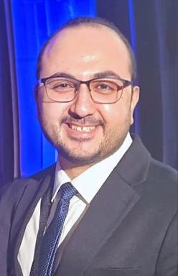 Moataz Abouammo

Identifiants chercheurs

- IdHAL : moataz-abouammo

Présentation

Dr. Moataz D. Abouammo, MD, PhD, is a Research Associate in the Department of Otolaryngology–Head and Neck Surgery at The Ohio State University Wexner Medical Center, where he also serves as Lab Director of the OSU-ALT-VISION Lab. Trained as an Otolaryngologist and Skull Base Surgeon in Egypt, where he worked as a Lecturer of Otolaryngology and Head – Neck Surgery at the Faculty of Medicine, Tanta University. He also completed a Rhinology and Skull Base Surgery fellowship at the Ohio State University Wexner Medical Center. Dr. Abouammo brings extensive expertise in surgical anatomy, clinical research, innovative approaches to complex skull base and cranial pathologies, and 3D photogrammetry modeling in surgical education. A prolific innovator, he introduced the Nasofrontal Trephination Approach—a novel technique for accessing deep skull base lesions in the petrous apex, craniovertebral junction, and infratemporal fossa - which earned him the prestigious Rhoton Award at the 34th North American Skull Base Society Conference (NASBS 2025). His work on this technique was featured on the cover of the Operative Neurosurgery Journal (September 2024). He also developed the Nasopharyngo-Septal Butterfly Flap, a reconstruction method for skull base defects. In 2025, Dr. Abouammo was honored with the Ilija Karanfilov Award of Excellence in Research, the highest distinction bestowed by the Department of Otolaryngology–Head and Neck Surgery at Ohio State University for exceptional scholarly achievement. This award recognizes his transformative research program, which has advanced the understanding and treatment of skull base pathologies through high-impact publications, pioneering surgical techniques, and dedication to mentoring the next generation of surgeons. Dr. Abouammo also serves as course instructor for the State-of-the-Art Endoscopic Skull Base Surgery hands-on training program at the Ohio State University, Wexner Medical Center, and his research, documented in 50+ peer-reviewed publications, focuses on endoscopic endonasal and orbital approaches to the anterior, middle and posterior skull base fossa lesions, pathology and management of sinonasal and skull base neoplasms. Recognized internationally, he frequently presents at major conferences and contributes as a reviewer for leading otolaryngology, skull base surgery, and neurosurgery journals. His work bridges surgical anatomical discovery, surgical education, and clinical translation to improve patient outcomes in skull base surgery.

Publications

Article dans une revue (1)

Patient Characteristics and Treatment Outcomes of Nasopharyngeal Carcinoma in Nonendemic Regions
Mohammad Bilal Alsavaf,Matthew Marquardt,Moataz Abouammo,Menglin Xu,Ahmed Elguindyet al.
JAMA Network Open, 2025, 8 (3), pp.e251895. ⟨10.1001/jamanetworkopen.2025.1895⟩
Article dans une revue
hal-05010912v1

