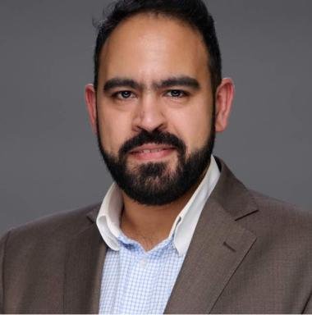 Mohamed Kayal Doctorate in Economic Sciences (University of Toulouse Jean Jaurès) between 2017 and 2020 under the supervision of Pr. François VELLAS, defended on September 25, 2020 in Toulouse.Associate researcher at LIRAES (URP 4470, Université Paris Cité) since July 1, 2024.Teaching and research in English and French

Identifiants chercheurs

- IdHAL : mohamed-kayal
- ORCID : 0000-0003-4936-4836
- IdRef : 255861567

Présentation

Doctorate in Economic Sciences (University of Toulouse Jean Jaurès) between 2017 and 2020 under the supervision of Pr. François VELLAS, defended on September 25, 2020 in Toulouse.Associate researcher at LIRAES (URP 4470, Université Paris Cité) since July 1, 2024.Teaching and research in English and French

Publications

Article dans une revue (3)

Climate change preventive measures: comparative approach between the UAE and Brazil
Mohamed Kayal
W. de Gruyter, In press
Article dans une revue
hal-04091370v1
Double Impact: A Macroeconomic Study of the Crossed Influences Between Climate Change and Business Tourism
Mohamed Kayal
The Law and Development Review, 2023, 17 (1), pp.263-295. ⟨10.1515/ldr-2023-0054⟩
Article dans une revue
hal-04905118v1
Climate change and the development of tourism in West Africa, the example of Senegal
Mohamed Kayal
Amazonian Journal Of International Development And Management Studies, 2023
Article dans une revue
hal-04940453v1

Chapitre d'ouvrage (1)

Sustainable Food Practices and Legal Regulations in Tourism/Sustainable Tourism
Mohamed Kayal
Gastronomy Law, , 2025, 978-989-9066-31-1. ⟨10.60559/gl23⟩
Chapitre d'ouvrage
hal-05380749v1

Thèse (1)

La spécialisation internationale touristique et le changement climatique
Mohamed Raef El Halabi El Kayal
Economies et finances. Université Toulouse le Mirail - Toulouse II, 2020. Français. ⟨NNT : 2020TOU20041⟩
Thèse
tel-03254281v1

