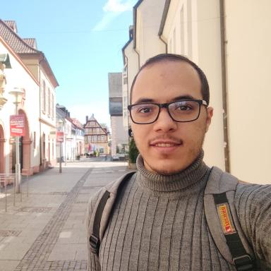 Mohammed Ghennai

Publications

Poster de conférence (1)

Self-Supervised Learning for Transcribing Spontaneous Speech of Children (3-6 Years Old)
Mohammed Ghennai,Benjamin Lecouteux,Solange Rossato,Aurélie Nardy
Rencontres des Jeunes Chercheurs en Parole 2025, Nov 2025, Paris, France
Poster de conférence
hal-05477475v1

