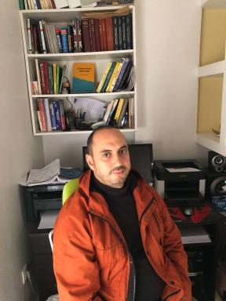 Mohammed Hichem Mortad

Publications

Communication dans un congrès (3)

Conditions yielding the commutativity of unbounded self-adjoint operators
Mohammed Hichem Mortad,Ahmed Ben Bella
Journées de Théorie des Opérateurs, oragniséees par Pr. Gilles Cassier (http://math.univ-lyon1.fr/~cassier/JTO_2016.pdf), Sep 2016, Lyon, France
Communication dans un congrès
hal-03466439v1
Exponentials of Bounded Normal Operators and Commutativity
Mohammed Hichem Mortad
Tenth ACOTCA: 11-14 June, 2013 in Sevilla, Jun 2013, Seville, Spain
Communication dans un congrès
hal-03453031v1
The Unbounded Product of Normal Operators
Mohammed Hichem Mortad
Ninth ACOTCA: 11-14 June, 2012 in Sevilla, Jun 2012, Seville, Spain
Communication dans un congrès
hal-03453025v1

Cours (2)

Advanced Linear Algebra: Exercises sheet 3
Mohammed Hichem Mortad
Master. Algeria. 2024
Cours
hal-04570174v1
(SQUARE) ROOTS OF BOUNDED OPERATORS
Mohammed Hichem Mortad
Master. Algeria. 2020
Cours
hal-03453063v1

