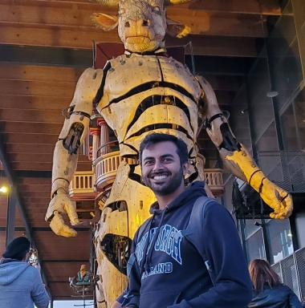 Mohit VAISHNAV PhD Researcher

Identifiants chercheurs

- IdHAL :
mohitvaishnav
- ORCID :
0000-0002-9795-493X

Publications

Article dans une revue (1)

Understanding the computational demands underlying visual reasoning
Mohit Vaishnav,Remi Cadene,Andrea Alamia,Drew Linsley,Rufin Vanrullenet al.
Neural Computation, 2022, pp.1-25. ⟨10.1162/neco_a_01485⟩
Article dans une revue
hal-03318448v1

Pré-publication, Document de travail (2)

Conviformers: Convolutionally guided Vision Transformer
Mohit Vaishnav,Thomas Fel,Ivań Felipe Rodríguez,Thomas Serre
2022
Pré-publication, Document de travail
hal-03819600v1
MAREO: Memory- and Attention- based visual REasOning
Mohit Vaishnav,Thomas Serre
2022
Pré-publication, Document de travail
hal-03819617v1

Communication dans un congrès (1)

A Benchmark for Compositional Visual Reasoning
Aimen Zerroug,Mohit Vaishnav,Julien Colin,Sebastian Musslick,Thomas Serre
Neural Information Processing Systems Track on Datasets and Benchmarks 2022, Nov 2022, New Orleans, United States
Communication dans un congrès
hal-03819614v1

