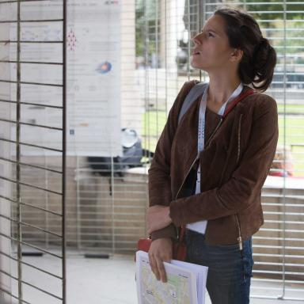 Morgane Gandil

Identifiants chercheurs

- IdHAL : morgane-gandil
- ORCID : 0000-0001-7369-7089
- IdRef : 203921747
- ResearcherID : http://www.researcherid.com/rid/P-6235-2014

Présentation

Publications

Article dans une revue (3)

Spectroscopic signatures of spin-orbit coupling and free excitons in individual suspended carbon nanotubes
Morgane Gandil,Kazunari Matsuda,Brahim Lounis,Philippe Tamarat
Physical Review B: Condensed Matter and Materials Physics (1998-2015), 2019, 100 (8), ⟨10.1103/PhysRevB.100.081411⟩
Article dans une revue
hal-02276555v1
Photoswitchable Single-Walled Carbon Nanotubes for Super-Resolution Microscopy in the Near-Infrared
Antoine G. Godin,Antonio Setaro,Morgane Gandil,Rainer Haag,Mohsen Adeliet al.
Science Advances , 2019, 5 (9), pp.eaax1166. ⟨10.1126/sciadv.aax1166⟩
Article dans une revue
hal-02077592v1
Unsteady deformations of a free liquid surface caused by radiation pressure
Bruno Issenmann,Régis Wunenburger,Hamza Chraibi,Morgane Gandil,Jean-Pierre Delville
Journal of Fluid Mechanics, 2011, 682, pp.460-490. ⟨10.1017/jfm.2011.236⟩
Article dans une revue
hal-00617568v1

Thèse (1)

Propriétés magnéto-optiques de nanotubes de carbone individuels suspendus
Morgane Gandil
Autre [cond-mat.other]. Université de Bordeaux, 2017. Français. ⟨NNT : 2017BORD0647⟩
Thèse
tel-01585256v1

Communication dans un congrès (1)

Magneto-photoluminescence spectroscopy of bright and dark excitons in suspended semiconducting single-walled carbon nanotubes
Morgane Gandil,Kazunari Matsuda,Philippe Tamarat,Brahim Lounis
Annual Meeting of the GDR-I Graphene Nanotubes, Oct 2016, Saint Pierre d'Oléron, France
Communication dans un congrès
hal-01636717v1

Poster de conférence (3)

Magneto-photoluminescence spectroscopy of bright and dark excitons in isolated semiconducting single-walled carbon nanotubes
Morgane Gandil,Kazunari Matsuda,Philippe Tamarat,Brahim Lounis
Trends in Nanotechnology International Conference, Sep 2015, Toulouse, France
Poster de conférence
hal-01203376v1
Magneto-photoluminescence of individual semiconducting single-walled carbon nanotubes
Morgane Gandil,Jonah Shaver,Philippe Tamarat,Brahim Lounis
LAPHIA international symposium, Sep 2014, Talence, France
Poster de conférence
hal-01203395v1
Magneto-photoluminescence of individual semiconducting single-walled carbon nanotubes
Morgane Gandil,Jonah Shaver,Philippe Tamarat,Brahim Lounis
Condensed Matter in Paris, Aug 2014, Paris, France
Poster de conférence
hal-01203394v1

