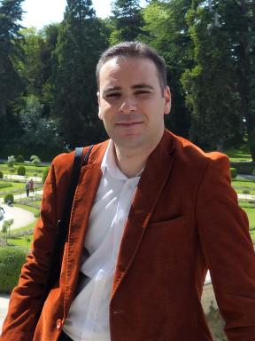 Mouhieddine Kherouatou Enseignant chercheur Département d'architecture. Université de Constantine 3 Salah Boubnider

Identifiants chercheurs

- IdHAL : mouhieddine-kherouatou
- ORCID : 0000-0002-9017-7162

Présentation

Mouhieddine Kherouatou is an Assistant Professor in the Department of Architecture at the University of Constantine 3, he works on the architectural heritage of the city of Constantine, and is interested in his research on the Ottoman history of the city through the reading of archives from the Ottoman administration. He is preparing a doctoral thesis entitled: “Architectural and urban productions of the city of Constantine during the Ottoman period”

Publications

