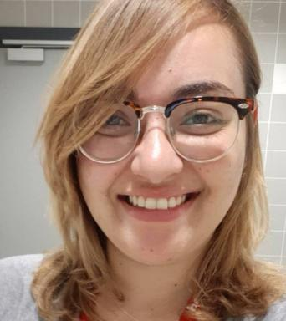 Mouna BEN SALEM

Présentation

Publications

Article dans une revue (3)

A drug delivery device concept using a miniature tubular linear electromagnetic actuator: design, modeling and experimental validation
Mouna Ben Salem,Laurent Petit,Muneeb Ullah Khan,Jérémy Terrien,Christine Prelleet al.
Journal of Micro-Bio Robotics, 2023, ⟨10.1007/s12213-023-00153-w⟩
Article dans une revue
hal-04107335v1
Microbiota Sampling Capsule: Design, Prototyping and Assessment of a Sealing Solution Based on a Bistable Mechanism
Mouna Ben Salem,Guillaume Aiche,Yassine Haddab,Lennart Rubbert,Pierre Renaud
Journal of Medical Devices, 2022, 16 (4), pp.041009. ⟨10.1115/1.4055250⟩
Article dans une revue
hal-03831488v1
Characterization of bistable mechanisms for microrobotics and mesorobotics
Mouna Ben Salem,Hussein Hussein,Guillaume Aiche,Yassine Haddab,Philippe Lutzet al.
Journal of Micro-Bio Robotics, 2019, 15 (1), pp.65-77. ⟨10.1007/s12213-019-00113-3⟩
Article dans une revue
lirmm-02076914v1

Communication dans un congrès (5)

A Miniature Tubular Linear Electromagnetic Actuator: Design, Modeling and Experimental Validation
Mouna Ben Salem,Laurent Petit,Muneeb U Khan,Jeremy Terrien,Christine Prelleet al.
International Conference on Manipulation, Automation and Robotics at Small Scales (MARSS), Jul 2022, Toronto, Canada. ⟨10.1109/MARSS55884.2022.9870253⟩
Communication dans un congrès
hal-03837852v1
Additive Manufacturing of a Bistable Mechanism Using Fused Deposition Modeling: Experimental and Theoretical Characterization
Mouna Ben Salem,Guillaume Aiche,Yassine Haddab,Lennart Rubbert,Pierre Renaud
MR 2019 - 43rd Mechanisms and Robotics Conference @IDETC-CIE, Aug 2019, Anaheim, United States. ⟨10.1115/DETC2019-97872⟩
Communication dans un congrès
hal-03831489v1
Mechanical Bistable Structures for Microrobotics and Mesorobotics from Microfabrication to Additive Manufacturing
Yassine Haddab,Guillaume Aiche,Hussein Hussein,Mouna Ben Salem,Philippe Lutzet al.
MARSS: Manipulation, Automation and Robotics at Small Scales, Jul 2018, Nagoya, Japan. pp.1-6, ⟨10.1109/MARSS.2018.8481186⟩
Communication dans un congrès
lirmm-02006548v1
Design of a Microbiota Sampling Capsule using 3D-Printed Bistable Mechanism
Mouna Ben Salem,Guillaume Aiche,Lennart Rubbert,Pierre Renaud,Yassine Haddab
EMBC 2018 - 40th International Conference of the IEEE Engineering in Medicine and Biology Society, Jul 2018, Honolulu, United States. pp.4868-4871, ⟨10.1109/EMBC.2018.8513141⟩
Communication dans un congrès
lirmm-02020447v1
Design of ingestible intestinal content sampler
Thomas Soranzo,Yassine Haddab,Philippe Cinquin,Pierre Renaud,Mouna Ben Salemet al.
Surgetica, Nov 2017, Strasbourg, France
Communication dans un congrès
hal-04238101v1

Thèse (1)

Développement d'une capsule de prélèvement de microbiote intestinal utilisant un mécanisme bistable et exploitant la fabrication additive
Mouna Ben Salem
Micro et nanotechnologies/Microélectronique. Université Montpellier, 2020. Français. ⟨NNT : 2020MONTS002⟩
Thèse
tel-02935847v2

