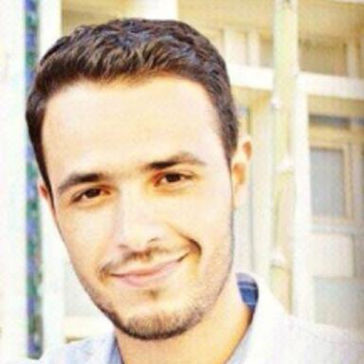 Moustafa SEBAA

Identifiants chercheurs

- IdHAL : moustafa-sebaa

Présentation

Publications

Communication dans un congrès (1)

Crystallization-induced damage in rocks using quasi-simultaneous X-ray and neutron tomography
Victor Okumko,Moustafa Sebaa,Alessandro Tengattini,Hannelore Derluyn,Luc Helfenet al.
The Biot-Bazant conference, Jun 2021, Evanston, United States
Communication dans un congrès
hal-04755260v1

