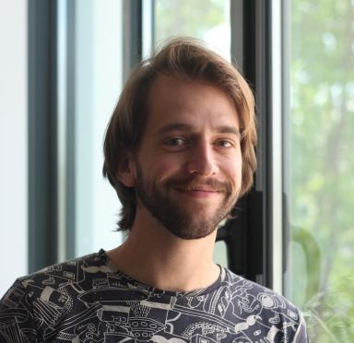 Matthieu SAGOT

Identifiants chercheurs

- IdHAL :
msagot
- ORCID :
0000-0003-1403-7405
- IdRef :
277047692

Publications

Article dans une revue (2)

Functionality integration in stereolithography 3D printed microfluidics using a “print-pause-print” strategy
Matthieu Sagot,Timothée Derkenne,Perrine Giunchi,Yohan Davit,Jean-Philippe Nougayrèdeet al.
Lab on a Chip, 2024, 24 (14), pp.3508-3520. ⟨10.1039/D4LC00147H⟩
Article dans une revue
hal-04632660v1
Bio-Impedance Spectroscopy of Retained Cells Using a Micro-Perforated Sensing Membrane Filtrating Whole Blood Samples under High Flowrate
Matthieu Sagot,Elise Bou,David Bourrier,Aline Cerf,Hervé Aubertet al.
Biosensors, 2023, 13 (12), pp.996. ⟨10.3390/bios13120996⟩
Article dans une revue
hal-04299355v1

Poster de conférence (3)

Clip-Chips: 3D printed microfluidic and characterization modules for cell culture applications
M Sagot,D Rojas,David Bourrier,A Arcas,A Ferrandet al.
NanoBioTech 2024, Nov 2024, Montreux, Switzerland. 2024
Poster de conférence
hal-04885986v1
Function integration in 3D-Printed µFluidics using a &quot;Print Pause Print&quot; Strategy
Matthieu Sagot,Elise Bou,Timothée Derkenne,C. Tregouet,Vincent Raimbaultet al.
MicroTAS, Oct 2023, Katowice, Poland. 2023
Poster de conférence
hal-04623218v1
3D Integration of a µSieve for Particle Filtration Combined with real-time in-situ Analysis within Complex Media
Matthieu Sagot,Bastien Venzac,David Bourrier,Aurélie Lecestre,Adrian Labordeet al.
Micro and Nano Engineering Conference 2023, Sep 2023, Berlin, Germany. , 2023
Poster de conférence
hal-04582810v1

