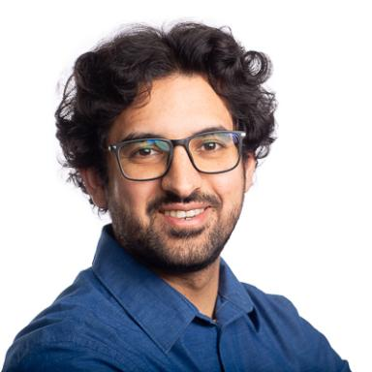 Muhammad Arsalan Khawaja PhD Candidate at NTNU, Norway and UBE, France

Identifiants chercheurs

- IdHAL : muhammad-arsalan-khawaja
- ORCID : 0009-0003-6820-2792

Présentation

Hi! I'm Arsalan, a computer vision researcher trying to teach machines to see the world in ways humans can't. I grew up fascinated by flight and earned my aerospace engineering degree (with a gold medal!). But I became even more captivated by how we can use cameras and algorithms to perceive and help machines understand the world which sometimes somethings are invisible to our eyes, From detecting early bruises in agriculture products before they're visible, to helping doctors see inside the human body in with AI based medical imaging, to assisting cultural heritage professionals digitize and understand historical artifacts using Computer Vision.
Now I'm completing my PhD across two countries (Norway and France), working on AI systems that capture and model how light interacts with surfaces. My research and curiosity has taken me from Viking-age textiles in Oslo museums to operating rooms in France, always asking: &quot;How can we make machines see better?&quot; I love projects where computer vision meets real-world messiness: autonomous robots navigating unknown environments, sensors struggling with weird lighting, defects hiding just below the surface. The gap between &quot;works in the lab&quot; and &quot;works on the wild&quot; is where things get interesting.
Currently I am based in the beautiful small town of Gjøvik in Norway, where I balance PhD thesis writing with padel playing, cross country sking, and walking along beautiful lake of Mjøsa. Looking forward for new opportunities to collaborate on interesting projects that life will bring to me

Publications

Article dans une revue (2)

Beyond relighting: RTI for clustering fragmented heritage textiles using deep learning
Muhammad Arsalan Khawaja,Davit Gigilashvili,Tomasz Łojewski,Sony George,Franck Marzaniet al.
npj Heritage Science, 2026, 14 (1), pp.95. ⟨10.1038/s40494-026-02326-9⟩
Article dans une revue
hal-05517987v1
Can Surface Topography Give Us Best Light Positions for Reflectance Transformation Imaging?
Muhammad Arsalan Khawaja,Sony George,Franck Marzani,Jon Yngve Hardeberg,Alamin Mansouri
Archiving Conference, 2023, 20 (1), pp.12-17. ⟨10.2352/issn.2168-3204.2023.20.1.3⟩
Article dans une revue
hal-04455111v1

Communication dans un congrès (3)

Apple bruise detection using hyperspectral imaging
Abdelhamid Fsian,Muhammad Arsalan Khawaja,Milan Kresovic,Leonardo Righetto,Jon Yngve Hardeberg
Seventeenth International Conference on Digital Image Processing (ICDIP 2025), Apr 2025, Haikou, China. ⟨10.1117/12.3075704⟩
Communication dans un congrès
hal-05364849v1
Self-supervised classification of surfaces using reflectance transformation imaging
Muhammad Arsalan Khawaja,Sony George,Franck Marzani,Jon Yngve Hardeberg,Alamin Mansouri
12th Colour and Visual Computing Symposium 2024 (CVCS 2024), Sep 2024, Gjøvik, Norway
Communication dans un congrès
hal-04984644v1
An interactive method for adaptive acquisition in Reflectance Transformation Imaging for cultural heritage
Muhammad Arsalan Khawaja,Sony George,Franck Marzani,Jon Yngve Hardeberg,Alamin Mansouri
2023 IEEE/CVF International Conference on Computer Vision Workshops (ICCVW), Oct 2023, Paris, France. pp.1690-1698, ⟨10.1109/ICCVW60793.2023.00185⟩
Communication dans un congrès
hal-04455086v1

