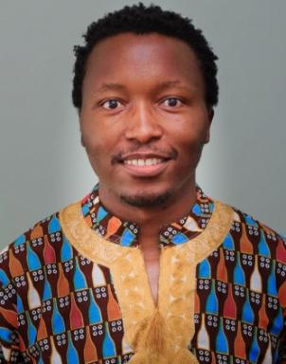 Musa Nxele Academic | Researcher | Entrepreneur

Identifiants chercheurs

- IdHAL : musa-nxele

Présentation

Musa Nxele is a lecturer at the Nelson Mandela School, where he convenes Masters courses and research related to political economy of development. He has a PhD in Development Policy and Practice from UCT. He is currently completing a PhD in Economics at the Université de Paris 1 Panthéon-Sorbonne and. He also holds Masters degrees from both universities, in economic development and globalisation. Before moving to tertiary education teaching in 2017, Musa worked in the private sector in the fields of investment banking and industrial development consulting. He dedicates his life to the transformation of people and societies; driven by hope, and the incredible story of his hometown, Soweto.

Publications

