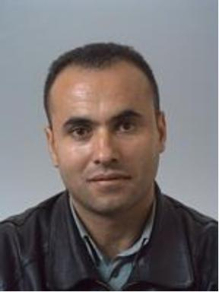 Nazeer ASMAEL

Identifiants chercheurs

- IdHAL : nazeer

Publications

Article dans une revue (4)

Hydro-Geochemical Characteristics of the Shallow Alluvial Aquifer and Its Potential Artificial Recharge to Sustain the Low Flow of the Garonne River
Nazeer Asmael,Alain Dupuy,Paul Mclachlan,Michel Franceschi
Water, 2023, 15 (16), pp.2972. ⟨10.3390/w15162972⟩
Article dans une revue
hal-04187045v1
Integrative Approach for Groundwater Pollution Risk Assessment Coupling Hydrogeological, Physicochemical and Socioeconomic Conditions in Southwest of the Damascus Basin
Nazeer Asmael,Jessica D Villanueva,Nicolas Peyraube,Mohamed Baalousha,Frédéric Huneauet al.
Water, 2021, 13 (9), pp.1220. ⟨10.3390/w13091220⟩
Article dans une revue
hal-03936712v1
Groundwater Modeling as an Alternative Approach to Limited Data in the Northeastern Part of Mt. Hermon (Syria), to Develop a Preliminary Water Budget
Nazeer Asmael,Alain Dupuy,Frédéric Huneau,Salim Hamid,Philippe Coustumer
Water, 2015, 7 (12), pp.3978-3996. ⟨10.3390/w7073978⟩
Article dans une revue
hal-03936742v1
Origin and recharge mechanisms of groundwater in the upper part of the Awaj River (Syria) based on hydrochemistry and environmental isotope techniques
Nazeer Asmael,F. Huneau,E. Garel,H. Celle-Jeanton,P. Le Coustumeret al.
Arabian Journal of Geosciences, 2015, 8 (12), pp.10521-10542. ⟨10.1007/s12517-015-1953-x⟩
Article dans une revue
hal-03936723v1

Communication dans un congrès (2)

Garonne River Behavior Under Climate Change and the Potential Adaptation Strategies Chapter 14
Nazeer Asmael,Alain Dupuy,Sophie Lele,Paul Mclachlan,Francois Larroqueet al.
Water Resources Management and Sustainability, 2024, Dubai, United Arab Emirates. ⟨10.1007/978-3-031-80520-2⟩
Communication dans un congrès
hal-05029364v1
Artificial Recharge of the Shallow Alluvial Aquifer as an Adaptation Strategy in the Garonne Valley, France
Nazeer Asmael,Alain Dupuy,Bernard Leroy
IAHS, 385, 53–58, 2024, May 2022, Montpellier, France. pp.53-58, ⟨10.5194/piahs-385-53-2024⟩
Communication dans un congrès
hal-05029264v1

