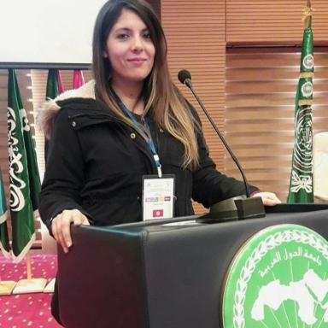 Nedra Amara

Publications

Article dans une revue (1)

Prediction of an educational institute learning environment using machine learning and data mining
Muhammad Shoaib,Nasir Sayed,Nedra Amara,Abdul Latif,Sikandar Azamet al.
Education and Information Technologies, 2022, 27 (7), pp.9099-9123. ⟨10.1007/s10639-022-10970-4⟩
Article dans une revue
hal-04574215v1

Communication dans un congrès (3)

Machine Learning Based-Proactive Caching for Cellular Networks
Nedra Amara
Proceedings of the 39th International Conference on Advanced Information Networking and Applications (AINA-2025), Volume 4, Apr 2025, Catalogne, Spain. pp.61-76, ⟨10.1007/978-3-031-87772-8_6⟩
Communication dans un congrès
hal-05455754v1
Applying Multiple Instance Learning for Breast Cancer Lesion Detection in Mammography Images
Nedra Amara,Said Gattoufi
10th International Conference on Information and Communication Technologies for Ageing Well and e-Health, Apr 2024, Angers, France. pp.93-97, ⟨10.5220/0012689500003699⟩
Communication dans un congrès
hal-04574228v1
Design of a Breast Image Data Warehouse Framework
Nedra Amara,Olfa Lamouchi,Said Gattoufi
2020 International Multi-Conference on: “Organization of Knowledge and Advanced Technologies” (OCTA), Feb 2020, Tunis, France. pp.1-13, ⟨10.1109/OCTA49274.2020.9151855⟩
Communication dans un congrès
hal-04574230v1

Chapitre d'ouvrage (1)

Implementation of a Medical Data Warehouse Framework to Support Decisions
Nedra Amara,Olfa Lamouchi,Said Gattoufi
Advances in Computer Vision and Computational Biology, Springer International Publishing, pp.521-536, 2021, Transactions on Computational Science and Computational Intelligence, ⟨10.1007/978-3-030-71051-4_41⟩
Chapitre d'ouvrage
hal-04574225v1

Pré-publication, Document de travail (1)

A Robust Secure Communication Protocol for Wireless Sensor Networks in Industrial Environments
Nedra Amara,Muhammad Shoaib Shoaib,Ahmed Junaid Junaid,Nasir Sayed Sayed
2024
Pré-publication, Document de travail
hal-04574222v1

