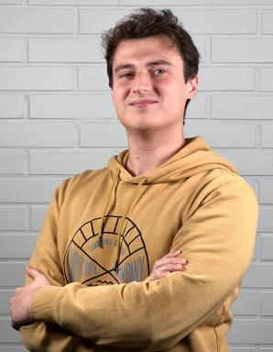 Niccolò Fonio

Identifiants chercheurs

- IdHAL : niccolo-fonio
- ORCID : 0009-0009-3815-7605
- arXiv : fonio_n_1

Publications

Pré-publication, Document de travail (3)

Two-dimensional quantum lattice gas algorithm for anisotropic Burger-like equations
Niccoló Fonio,Pierre Sagaut,Giuseppe Di Molfetta
2026
Pré-publication, Document de travail
hal-05523609v1
Adaptive Lattice Gas Algorithm: Classical and Quantum implementations
Niccolò Fonio,Ljubomir Budinski,Valtteri Lahtinen,Pierre Sagaut
2025
Pré-publication, Document de travail
hal-05122304v1
Quantum collision circuit, quantum invariants and quantum phase estimation procedure for fluid dynamic lattice gas automata
Niccolo Fonio,Pierre Sagaut,Giuseppe Di Molfetta
2025
Pré-publication, Document de travail
hal-04543971v2

