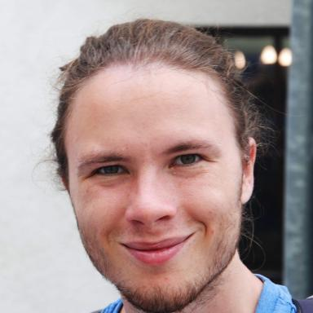 Nicolas Pinon Post-doctorant à CREATIS

Présentation

Publications

Article dans une revue (2)

GAN-based synthetic FDG PET images from T1 brain MRI can serve to improve performance of deep unsupervised anomaly detection models
Daria Zotova,Nicolas Pinon,Robin Trombetta,Romain Bouet,Julien Junget al.
Computer Methods and Programs in Biomedicine, 2025, 265, pp.108727. ⟨10.1016/j.cmpb.2025.108727⟩
Article dans une revue
hal-05061806v1
Improving motion‐mask segmentation in thoracic CT with multiplanar U‐nets
Ludmilla Penarrubia,Nicolas Pinon,Emmanuel Roux,E.E. Dávila Serrano,Jean-Christophe Richardet al.
Medical Physics : The international journal of medical physics research and practice, 2022, 49 (1), pp.420-431. ⟨10.1002/mp.15347⟩
Article dans une revue
hal-03464276v1

Communication dans un congrès (4)

One-Class SVM on siamese neural network latent space for Unsupervised Anomaly Detection on brain MRI White Matter Hyperintensities
Nicolas Pinon,Robin Trombetta,Carole Lartizien
MIDL 2023, Jul 2023, Nashville, United States
Communication dans un congrès
hal-04067715v1
Brain subtle anomaly detection based on auto-encoders latent space analysis : application to de novo parkinson patients
Nicolas Pinon,Geoffroy Oudoumanessah,Robin Trombetta,Michel Dojat,Florence Forbeset al.
ISBI 2023 - IEEE 20th International Symposium on Biomedical Imaging, Apr 2023, Cartegena de Indias, Colombia. pp.1-5, ⟨10.1109/ISBI53787.2023.10230351⟩
Communication dans un congrès
hal-03998623v1
Détection d'anomalies dans l'espace image ou l'espace latent d'auto-encodeurs par patch pour l'analyse d'images industrielles
Nicolas Pinon,Robin Trombetta,Carole Lartizien
GRETSI 2023 : XXIXème Colloque Francophone de Traitement du Signal et des Images, Aug 2023, Grenoble, France
Communication dans un congrès
hal-04147526v1
Patch vs. Global Image-Based Unsupervised Anomaly Detection in MR Brain Scans of Early Parkinsonian Patients
Verónica Muñoz-Ramírez,Nicolas Pinon,Florence Forbes,Carole Lartizien,Michel Dojat
MLCN 2021 - 4th International Workshop in Machine Learning in Clinical Neuroimaging, Sep 2021, Strasbourg, France. pp.34-43, ⟨10.1007/978-3-030-87586-2_4⟩
Communication dans un congrès
hal-03397081v1

Pré-publication, Document de travail (1)

OCSVM-Guided Representation Learning for Unsupervised Anomaly Detection
Nicolas Pinon,Carole Lartizien
2025
Pré-publication, Document de travail
hal-05164029v2

Thèse (2)

Unsupervised anomaly detection in neuroimaging: contributions to representation learning and density support estimation in the latent space
Nicolas Pinon
Artificial Intelligence [cs.AI]. INSA Lyon, 2024. English. ⟨NNT : 2024ISAL0031⟩
Thèse
tel-04886248v1
Unsupervised anomaly detection in neuroimaging : Contributions to representation learning and density support estimation in the latent space
Nicolas Pinon
Medical Imaging. INSA de Lyon, 2024. English. ⟨NNT : 2024ISAL0031⟩
Thèse
tel-04884652v1

