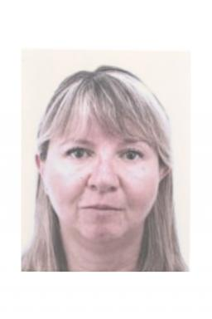 Rita Nugem

Identifiants chercheurs

- IdHAL : nugem-rita
- ORCID : 0000-0002-8713-0187

Publications

Article dans une revue (3)

Behavioral Profiles and Sociodemographic Predictors of Planetary Health Diet Engagement Among Health Care Professionals to Inform Public Health Promotion: Cross-Sectional Study
Florence Carrouel,Rita Nugem,Laurie Fraticelli,Yohan Fayet,Lama Basbouset al.
JMIR Public Health and Surveillance, 2025, 11, pp.e67633. ⟨10.2196/67633⟩
Article dans une revue
hal-05361824v1
Stroke Care in Brazil and France: National Policies and Healthcare Indicators Comparison
Rita Nugem,Ronaldo Bordin,Christophe Pascal,Anne-Marie Schott-Pethelaz,Beatrice Trombert-Paviotet al.
Journal of Multidisciplinary Healthcare, 2020, Volume 13, pp.1403-1414. ⟨10.2147/JMDH.S262900⟩
Article dans une revue
hal-05043318v1
UMA ANÁLISE DA EDUCAÇÃO EM SAÚDE NA REDUÇÃO DOS INDICADORES DE INFECÇÃO PRIMÁRIA RELACIONADA A CATETER VENOSO CENTRAL
Joseane Stahl Silveira,Rita De Cassia Nugem
Revista Gestão & Saúde, 2019, 10 (3), pp.424-438. ⟨10.26512/gs.v10i3.26397⟩
Article dans une revue
hal-04751828v1

Thèse (1)

Effectiveness on stroke health care : a comparison between Brazil and France
Rita de Cassia Nugem
Santé publique et épidémiologie. Université de Lyon; Universidade do Rio Grande do Sul -- Porto Alegre (Brésil), 2021. English. ⟨NNT : 2021LYSE1018⟩
Thèse
tel-03622959v1

Proceedings/Recueil des communications (2)

Inadequated environmental sanitation diseases (IESDs) in Porto Alegre – RS/ Brasil
Rita Nugem,Roger Rosa Rs Santos Rosa,Ronaldo Bordin R Bordin,Caroline Teixeira Cn Nugem Teixeira
Proceedings of the 4th IPLeiria’s International Health Congress, BMC Health Services Research, 18 (S2), pp.684, 2018, ⟨10.1186/s12913-018-3444-8⟩
Proceedings/Recueil des communications
hal-04751961v1
Trend in obesity in an aging society: an estimate of obese elderly in Brazil in 2030.
Rita Nugem,Ronaldo Bordin R Bordin,Roger Rosa Rs Santos Rosa,Adriane Carvalho A Carvalho
Proceedings of the 4th IPLeiria’s International Health Congress, BMC Health Services Research, 18 (S2), pp.684, 2018, ⟨10.1186/s12913-018-3444-8⟩
Proceedings/Recueil des communications
hal-04751925v1

