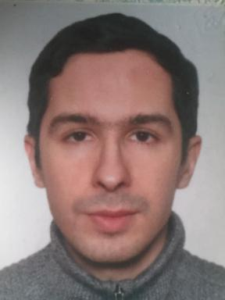 Oleksandr Galychyn

Identifiants chercheurs

- IdHAL : oleksandr-galychyn
- ORCID : 0000-0002-5875-672X

Publications

Article dans une revue (8)

An urban emergy footprint: Comparing supply- and use-extended input-output models for the case of Vienna, Austria
Oleksandr Galychyn,B.D. Fath,D. Wiedenhofer,E. Buonocore,P.P. Franzese
Cleaner Production Letters, 2024, 6, pp.100058. ⟨10.1016/j.clpl.2024.100058⟩
Article dans une revue
hal-04507173v1
Ecological network analysis of a metabolic urban system based on input–output tables: Model development and case study for the city of Vienna
Oleksandr Galychyn,B D Fath,E Buonocore,P P Franzese
Cleaner Production Letters, 2022, 3, ⟨10.1016/j.clpl.2022.100019⟩
Article dans une revue
hal-03812033v1
Organic Transportation Networks: Human-Oriented Renewal of Modern Megapolises
Oleksandr Galychyn,Shqiprim Ahmeti,Kevser Ustundag
The Academic Research Community Publication, 2019, ⟨10.21625/archive.v3i2.617⟩
Article dans une revue
hal-02415956v1
Embracing the Topological Complexity of Transportation Networks
Oleksandr Galychyn
Citation: Oleksandr Galychyn. Ijsrm.Human, 2017, 8, pp.94 - 105
Article dans une revue
hal-02416033v1
Physical Features of Gated Communities in Japan and USA: A Comparative Analysis
Oleksandr Galychyn
International Journal of Science and Research Methodology, 2017, pp.70-93
Article dans une revue
hal-02416047v1
Analysis of planning diagrams of underground railroads in large cities of the World
Oleksandr Galychyn
International Journal of Scientific & Engineering Research, 2013, 4, pp.407-412
Article dans une revue
hal-02415984v1
Project of subway station &quot;Yuzhnaya&quot; (south station) in Kharkiv
Oleksandr Galychyn
International Journal of Scientific & Engineering Research, 2013, 4
Article dans une revue
hal-02415999v1
論文要旨 論文題目 Analysis planning circuitry of underground railroads in greatest city's of World
Oleksandr Galychyn
Scientific and technical collection is the "Communal economy of cities", 2011, 99
Article dans une revue
hal-02416021v1

Thèse (1)

Towards sustainable cities: A multi-criteria assessment framework for studying urban metabolism
Oleksandr Galychyn
Environmental Sciences. Parthenope University of Naples, 2022. English. ⟨NNT : ⟩
Thèse
tel-04663211v2

Autre publication scientifique (1)

Issue:3 Citation: Oleksandr Galychyn
Oleksandr Galychyn
2018, pp.55 - 99
Autre publication scientifique
hal-02416054v1

Rapport (1)

Metodo di rilegatura giapponese per libri antichi
Oleksandr Galychyn
[Research Report] Eastern University of Naples. 2017
Rapport (rapport de recherche)
hal-02416073v1

