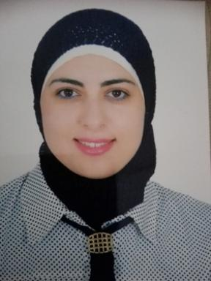 Olfa turki Maitre assistant

Présentation

Olfa Turki is a assistant Professor of Physics at the University of Tunis el Manar. She obtained her doctoral degree in Physics in 2017 from University of Sfax (FSS). She joined the Laboratory of Multifunctional Materials and Applications (LaMMA), Faculty of Sciences of Sfax. His research interests concern on Synthesis and characterization of ferroelectric, piezoelectric and multifunctional materials (ceramics and polymers).

Publications

Article dans une revue (4)

Enhancing nanostructure and energy harvesting efficiency in sustainable BCZT piezoelectric materials through calcination temperature optimization
Sarra Missaoui,Ayda Bouhamed,Ahmed Slimani,Uwe Zschenderlein,Olfa Turkiet al.
Ceramics International, 2025, ⟨10.1016/j.ceramint.2025.08.381⟩
Article dans une revue
hal-05253964v1
Sol-gel hydrothermal synthesis of lead-free BT nanoparticles for enhanced dielectric properties in PVDF nanocomposites
Olfa Turki,Ahmed Slimani,Sami Boufi,Laurence Seveyrat,Veronique Perrinet al.
Applied Surface Science, 2025, 679, pp.161242. ⟨10.1016/j.apsusc.2024.161242⟩
Article dans une revue
hal-04717075v1
Enhancement of dielectric, piezoelectric, ferroelectric, and electrocaloric properties in slightly doped (Na 0.5 Bi 0.5 ) 0.94 Ba 0.06 TiO 3 ceramic by samarium
Olfa Turki,Ahmed Slimani,Laurence Seveyrat,Zina Sassi,Hamadi Khemakhemet al.
Journal of Applied Physics, 2019, 125 (17), pp.174103. ⟨10.1063/1.5083670⟩
Article dans une revue
hal-02166235v1
Structural and relaxor behavior in lead-free (Ba0.8Sr0.2)Ti1-x(Zn1/3Nb2/3)(x)O-3 ceramics
Nabil Dhifallah,Olfa Turki,Mimoun El Marssi,Mohamed Dammak,Hamadi Khemakhem
Ceramics International, 2016, 42 (6), pp.6657-6663. ⟨10.1016/j.ceramint.2016.01.013⟩
Article dans une revue
hal-03627591v1

