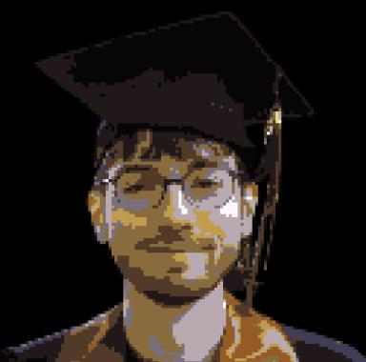 Olivier Bouët-Willaumez

Identifiants chercheurs

- IdHAL : olivierbouet-willaumez
- ORCID : 0009-0001-1744-9205

Présentation

I am currently a PhD student in Computer Science at the Laboratory of Algorithmics, Complexity, and Logic (LACL) at Université Paris-Est Créteil Val de Marne.
My PhD thesis is titled: Machine Learning for Continuous Systems Based on Probabilistic Approximations.
I began my PhD on October 1, 2024, under the supervision of Nihal Pekergin, Benoît Barbot, and Adrien Le Coënt.
Before that, I completed a Master’s degree in Mathematics, Modeling, and Statistical Learning (MMAS) at Université Paris Cité. During this time, I also completed a six-month internship at Dassault Systèmes, where I worked on deep Gaussian processes for multi-fidelity simulation.

Publications

Communication dans un congrès (1)

Sampling methods for probabilistic approximations of ODEs
Olivier Bouët-Willaumez,Adrien Le Coënt,Benoît Barbot,Nihal Pekergin
ROADEF 2026, 27ème congrès annuel de la Société Française de Recherche Opérationnelle et d'Aide à la Décision, Laboratoire d'Informatique Fondamentale et Appliquée de Tours (LIFAT), Feb 2026, Tours, France
Communication dans un congrès
hal-05440887v2

Pré-publication, Document de travail (1)

Conservation Analysis and Discrete Probabilistic Approximations for Parameter Estimation of Biochemical Networks
Olivier Bouët-Willaumez,Adrien Le Coënt,Benoît Barbot,Nihal Pekergin
2025
Pré-publication, Document de travail (preprint/prepublication)
hal-05104966v1

