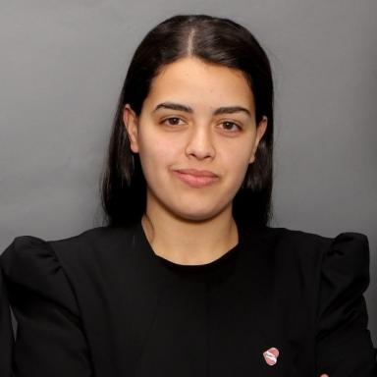 OUIDAD BENHLIMA

Présentation

Publications

Article dans une revue (1)

Development of a Variable Multimodal Balanced Floating Catchment Area Approach for Spatial Accessibility Assessment
Ouidad Benhlima,Fouad Riane,Jakob Puchinger,Hicham Bahi
Geographical Analysis, 2024, 56 (4), pp.678-699. ⟨10.1111/gean.12398⟩
Article dans une revue
hal-04530608v1

Communication dans un congrès (2)

An isochronic measurement for the analysis of proximity to restaurants and locations of food delivery parking
Ouidad Benhlima,Fouad Riane,Jakob Puchinger,Hicham Bahi
The 9th International Conference on Modeling, Simulation and Applied Optimization (ICMSAO’23), Apr 2023, Marrakech, Morocco. ⟨10.1063/5.0194609⟩
Communication dans un congrès
hal-04086908v1
Assessment of spatial accessibility to public hospitals in Casablanca by car
Ouidad Benhlima,Fouad Riane,Jakob Puchinger,Hicham Bahi
Transport Research Arena 2022, Nov 2022, Lisbon, Portugal. pp.2976-2983, ⟨10.1016/j.trpro.2023.11.844⟩
Communication dans un congrès
hal-03965702v2

