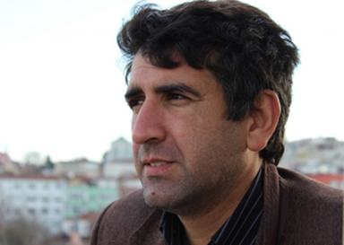 Özkan Karaca

Identifiants chercheurs

- IdHAL : ozkankaraca
- VIAF : 27165809342358971706
- ISNI : 0000000506748914
- ResearcherID : AAV-5128-2020

Présentation

İş Tel: +90 216 888 0094 Dahili:E-posta: ozkankaraca@msfproduksiyon.com.trURL: https://ozkankaraca.academia.edu/: https://dergipark.org.tr/tr/pub/@ozkankaraca: https://doi.org/10.7910/DVN/7ZZ6BO
He was born in 1977 in Malatya. He completed his primary education in Güngören Primary School in Istanbul (1988), Secondary School in Güngören Secondary School (1992), High School in Zeytinburnu Cevizlibağ Textile Technical Vocational High School (1996). He developed his writing style by maintaining his writing language and interest in literature over the years. His first article started at the age of 18 as a columnist in a local newspaper. He worked as an actual cameraman in Kanal 7 television organization, and after his military service, he worked in this organization for a while and left due to a job change. He first worked as a cameraman's assistant on the sets of television and TV series, and then actively participated as a cameraman in production works until today, especially in the Kurtlar Vadisi Pusu series. He professionally photographs nature and people through his lens. He worked in various jobs and engaged in trade. Since 2010, he started making documentaries.
He has photographed the services and aid activities of our country by being in many countries with various NGO organizations. His poems and articles; Aktüel, Ay Vakti, Fikir Yolu, Güllük, Hicran, İlkadım, İslami Edebiyat, Kara Kalem, Kumru, Küskün Akasya, Maki, Mavera, Sarı Çiğdem, Şiir Merdiveni, İmbik, Yüz Akı magazines. National academic; His articles were published in Amisos, Mecmua, Turkish & Islamic World Social Research, Historical Research, Social Science Research Network Jurnal journals. He has papers presented at national and international meetings. He is currently conducting research on recent history, Balkans and Middle East, history of Ottoman institutions and civilization, general Turkish history, art, media and cinema. He also writes movie scripts by combining story depiction with understanding the language of cinema, camera plan and angle technique. The organization that creates a quality technical infrastructure while producing various documentary films aimed at promoting the historical and cultural richness of our country by opening historical emotions and today's vital codes: Atlantik Medya and Production continues its activities as a producer and director for documentaries, series and television films. Founded in 2017, he continues his activities as the chairman of the board of directors of MSF Basın Yayın Prodüksiyon Eğitim Hizmetleri. He is a member of the Writers' Union of Turkey, the Professional Association of the Owners of Subscribe to DeepL Pro to edit this document. Visit Scientific and Literary Works (İLESAM), the Association for Literature, Art and Culture Research (ESKADER), the Association of Turkish Travelers and the Izollu Foundation.

Publications

