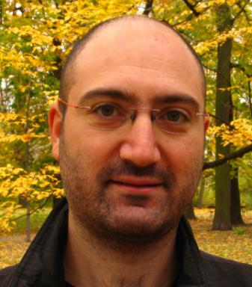 Giuseppe Patera

Publications

Article dans une revue (4)

Spatial localization and pattern formation in discrete optomechanical cavities and arrays
J. Ruiz-Rivas,Giuseppe Patera,C. Navarrete-Benlloch,E. Roldán,G.J. de Valcárcel
New Journal of Physics, 2020, 22 (9), pp.093076. ⟨10.1088/1367-2630/abb73e⟩
Article dans une revue
hal-02966280v1
Generalized approach for enabling multimode quantum optics
Elie Gouzien,Sébastien Tanzilli,Virginia d'Auria,Giuseppe Patera
Physical Review Letters, 2020, 125, pp.103601. ⟨10.1103/PhysRevLett.125.103601⟩
Article dans une revue
hal-02467011v1
Measuring nonclassicality of bosonic field quantum states via operator ordering sensitivity
Stephan de Bièvre,Dmitri B. Horoshko,Giuseppe Patera,Mikhail I. Kolobov
Physical Review Letters, 2019, 122 (8), pp.080402. ⟨10.1103/PhysRevLett.122.080402⟩
Article dans une revue
hal-01865597v1
Entanglement of quantum circular states of light
Horoshko D.,Stephan de Bievre,Mikhail I. Kolobov,Giuseppe Patera
Physical Review A : Atomic, molecular, and optical physics [1990-2015], 2016, ⟨10.1103/PhysRevA.93.062323⟩
Article dans une revue
hal-01408553v1

Pré-publication, Document de travail (2)

Quantum theory of Synchronously Pumped type I Optical Parametric Oscillators: characterization of the squeezed supermodes
Giuseppe Patera,Nicolas Treps,Claude Fabre,German J. de Valcarcel
2009
Pré-publication, Document de travail
hal-00407257v1
Squeezing frequency combs
German J. de Valcarcel,Giuseppe Patera,Nicolas Treps,Claude Fabre
2006
Pré-publication, Document de travail
hal-00068952v1

Communication dans un congrès (1)

High accuracy space time positionong beyond the standard quantum noise
C. Fabre,Nicolas Treps,Brahim Lamine,Giuseppe Patera,Benoît Chalopinet al.
XIII International Conference on Quantum Optics and Quantum Information, 2008, Vilnius, Lithuania
Communication dans un congrès
hal-00498059v1

Thèse (1)

Quantum properties of ultra-short pulses generated by SPOPOs: multi-mode squeezing and entanglement
Giuseppe Patera
Atomic Physics [physics.atom-ph]. Université Pierre et Marie Curie - Paris VI, 2008. English. ⟨NNT : ⟩
Thèse
tel-00404162v1

