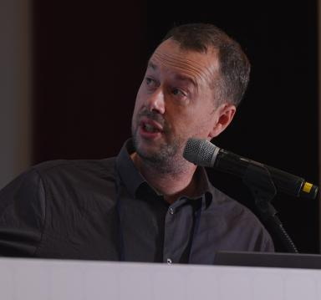 Patrice Thibaud

Identifiants chercheurs

- IdHAL : patrice-thibaud
- ORCID : 0009-0006-1996-2201

Publications

Communication dans un congrès (2)

When Voices Interleave: Timing Deviations in Six Performances of Telemann's Fantasias for Solo Flute
Patrice Thibaud,Mathieu Giraud,Yann Teytaut
International Society for Music Information Retrieval Conference (ISMIR 2025), Sep 2025, Daejeon, South Korea
Communication dans un congrès
hal-05102415v1
Analyse et essai de reconstruction de structures arborescentes des grilles de jazz
Patrice Thibaud,Mathieu Giraud
Journées d'Informatique Musicale (JIM 2023), May 2023, Paris, France. pp.62-67
Communication dans un congrès
hal-04196644v1

Autre publication scientifique (1)

Towards Detecting Interleaved Voices in Telemann Flute Fantasias
Patrice Thibaud,Mathieu Giraud,Yann Teytaut
DMRN+19: Digital Music Research Network One-day Workshop, 2024
Autre publication scientifique
hal-04923955v1

