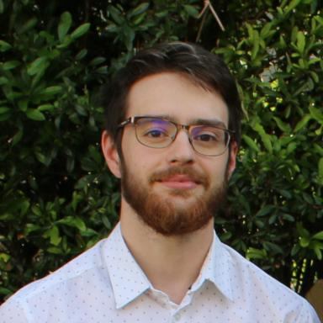 Pierre-Antoine Comby

Identifiants chercheurs

- IdHAL : pierre-antoine-comby
- ORCID : 0000-0001-6998-232X

Publications

Communication dans un congrès (7)

MRI-NUFFT: An open source Python package to make non-Cartesian MR Imaging easier
Pierre-Antoine Comby,Guillaume Daval-Frérot,Chaithya Gr,Alexandre Vignaud,Philippe Ciuciu
ISMRM & ISMRT 2025 - Annual Meeting & Exhibition, ISMRM, May 2025, Honolulu (Hawai), United States. ⟨10.58530/2024/4675⟩
Communication dans un congrès
hal-05373299v1
SNAKE-fMRI: A modular fMRI simulator from the space-time domain to k-space data and back
Pierre-Antoine Comby,Alexandre Vignaud,Philippe Ciuciu
ISMRM 2024 - ISMRM & ISMRT Annual Meeting, ISMRM, May 2025, Singapour, Singapore
Communication dans un congrès
hal-05373290v1
Robust plug-and-play methods for highly accelerated non-Cartesian MRI reconstruction
Pierre-Antoine Comby,Benjamin Lapostolle,Matthieu Terris,Philippe Ciuciu
2025 IEEE 22nd International Symposium on Biomedical Imaging (ISBI), Apr 2025, Houston, France. pp.1-5, ⟨10.1109/ISBI60581.2025.10980851⟩
Communication dans un congrès
hal-04759015v2
Plug-and-Play reconstruction for 3D non-cartesian fMRI data
Pierre-Antoine Comby,Matthieu Terris,Alexandre Vignaud,Philippe Ciuciu
33rd European Signal Processing Conference, EURASIP, Sep 2025, Palermo, Italy
Communication dans un congrès
hal-04993532v1
Achieving high temporal resolution using a sliding-window approach for SPARKLING fMRI data: A simulation study
Zaineb Amor,Pierre-Antoine Comby,Philippe Ciuciu,Alexandre Vignaud
ISMRM & ISMRT 2024 - Annual Meeting & Exhibition, ISMRM, May 2024, Singapore, Singapore
Communication dans un congrès
hal-04427082v1
Denoising of FMRI volumes using local low rank methods
Pierre-Antoine Comby,Zaineb Amor,Alexandre Vignaud,Philippe Ciuciu
ISBI 2023 - International Symposium on Biomedical Imaging, Apr 2023, Carthagena de India, Colombia. pp.1-5, ⟨10.1109/ISBI53787.2023.10230489⟩
Communication dans un congrès
hal-03895194v2
Non-Cartesian non-Fourier fmri imaging for high-resolution retinotopic mapping at 7 Tesla
Zaineb Amor,Pierre-Antoine Comby,Caroline Le Ster,Alexandre Vignaud,Philippe Ciuciu
CAMSAP 2023 - IEEE International Workshop on Computational Advances in Multi-Sensor Adaptive Processing, IEEE, Dec 2023, Los Suenos, Costa Rica
Communication dans un congrès
hal-04363378v1

Article dans une revue (2)

MRI-NUFFT: Doing non-Cartesian MRI has never been easier
Pierre-Antoine Comby,Guillaume Daval-Frérot,Caini Pan,Asma Tanabene,Léna Oudjmanet al.
Journal of Open Source Software, 2025, 10 (108), pp.7743. ⟨10.21105/joss.07743⟩
Article dans une revue
hal-04775262v1
SNAKE: A modular realistic fMRI data simulator from the space-time domain to k-space and back Open Access
Pierre-Antoine Comby,Alexandre Vignaud,Philippe Ciuciu
Imaging Neuroscience, 2024, 3, ⟨10.1162/IMAG.a.121⟩
Article dans une revue
hal-04533862v2

Thèse (1)

From Compressed Sensing to deep learning based methods for functional Magnetic Resonance Imaging reconstruction at ultra-high field
Pierre-Antoine Comby
Signal and Image Processing. Université Paris-Saclay, 2025. English. ⟨NNT : 2025UPAST031⟩
Thèse
tel-05048754v1

