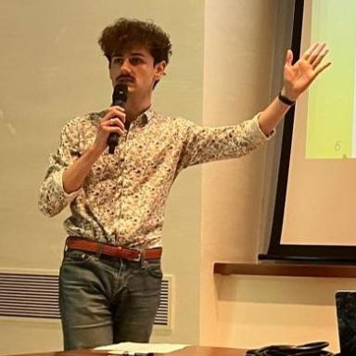 Pierre Veron Doctorant à l'Institut de biologie de l'École normale supérieure - PSL (IBENS)

Identifiants chercheurs

- IdHAL : pierre-veron
- ORCID : 0000-0003-2896-4250
- cv.identifier.google scholar : zMhd4LMAAAAJ

Présentation

Who I am
I’m Pierre Veron (he/him), third year PhD student in evolution and ecology at Institute of Biology of École Normale Supérieure (IBENS) and at Institute for the Diversity, Ecology and Evolution of the Living World of the Université Paris Saclay (IDEEV).
I’m interested in speciation research, my work focuses on theoretical predictions on the link between microevolution and macroevolution. I’m co-supervised by Hélène Morlon (Biodiv team) and Tatiana Giraud (Evolutionary Genetics and Ecology team).
What I do
I am working on modelisation of the different steps of speciation, with the aim to understand which microevolutionary processes modulate the rates of speciation in the living world.
To do so I rely on a modelisation approach, for instance using the holey adaptive landscape to analyse the influence of the parameters such as population size, mutation rate, outbreeding depression on the time for speciation in allopatric or parapatric mode.
Additionnaly, I work on more macroevolutionnary models such as the protracted birth death model of speciation (PBD) to analyse the most influent steps of speciation (population splitting, accumulation of reproductive isolation, population survival).
My full CV can be found here.

Publications

Article dans une revue (3)

Speciation completion rates have limited impact on macroevolutionary diversification
Pierre Veron,Jérémy Andréoletti,Tatiana Giraud,Hélène Morlon
Philosophical Transactions of the Royal Society B: Biological Sciences, 2024, A mathematical theory of evolution’: phylogenetic models dating back 100 years’, 380 (1919), pp.20230317. ⟨10.1098/rstb.2023.0317⟩
Article dans une revue
hal-04728750v2
Phylogenetic Insights into Diversification
Hélène Morlon,Jérémy Andréoletti,Joëlle Barido-Sottani,Sophia Lambert,Benoît Perez-Lamarqueet al.
Annual Review of Ecology, Evolution, and Systematics, 2024, 55, pp.1-21. ⟨10.1146/annurev-ecolsys-102722-020508⟩
Article dans une revue (article de synthèse)
hal-04631083v1
Environmental DNA complements scientific trawling in surveys of marine fish biodiversity
Pierre Veron,Romane Rozanski,Virginie Marques,Stéphane Joost,Marie Emilie Deschezet al.
ICES Journal of Marine Science, 2023, 80 (8), pp.2150-2165. ⟨10.1093/icesjms/fsad139⟩
Article dans une revue
hal-04313486v1

