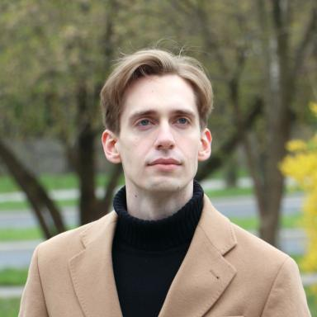 Piotr Wyroślak

Publications

Article dans une revue (4)

Disentangling constructional networks
Piotr Wyroślak,Dylan Glynn
Linguistics Vanguard : a Multimodal Journal for the Language Sciences, In press, ⟨10.1515/lingvan-2023-0035⟩
Article dans une revue
hal-04029311v1
Accusative-instrumental alternation in Polish
Piotr Wyroślak
Zeitschrift für Slawistik, 2023, 68 (1), pp.41-82. ⟨10.1515/slaw-2023-0002⟩
Article dans une revue
hal-04565114v1
No big deal
Piotr Wyroślak
Yearbook of the German Cognitive Linguistics Association, 2022, 10 (1), pp.77-98. ⟨10.1515/gcla-2022-0005⟩
Article dans une revue
hal-04565112v1
How morphologically related synonyms come to make up a paradigm
Björn Wiemer,Joanna Wrzesień-Kwiatkowska,Piotr Wyroślak
Russian Linguistics, 2020, 44 (3), pp.231-266. ⟨10.1007/s11185-020-09231-0⟩
Article dans une revue
hal-04565117v1

Communication dans un congrès (11)

Establishing constructionhood(s): The role of multimodal context in identifying constructions
Piotr Wyroślak
16th International Cognitive Linguistics Conference, Aug 2023, Düsseldorf, Germany
Communication dans un congrès
hal-04565219v1
Normativity management in discourse
Piotr Wyroślak
9th International Conference of the German Cognitive Linguistics Association, Mar 2022, Erfurt, Germany
Communication dans un congrès
hal-04565108v1
Delineating the scope of a benefactive alternation
Piotr Wyroślak
9th International Conference on Grammar & Corpora, Jun 2022, Gent, Belgium
Communication dans un congrès
hal-04565111v1
The accusative-instrumental alternation in seventeenth-eighteenth century Polish: the relation with aspect
Piotr Wyroślak
Slavic aspect and (diachronic) corpora, Mar 2021, Mainz, Germany
Communication dans un congrès
hal-04565321v1
Between normativity management, benefaction and volitionality: Polish dative reflexive pronoun se/sobie
Piotr Wyroślak
4th Białystok-Kiev conference on Theoretical and Applied Linguistics, Dec 2021, Białystok, Poland
Communication dans un congrès
hal-04565232v1
Polish reflexive pronoun sobie: understanding the ‘ethical’ uses
Piotr Wyroślak
8th International Conference on Grammar & Corpora, Nov 2020, Kraków, Poland
Communication dans un congrès
hal-04565327v1
Paradigmatic constructions
Dylan Glynn,Piotr Wyroślak
11th International Conference on Construction Grammar (ICCG 11), 2020, Antwerp, Belgium
Communication dans un congrès
hal-04029325v1
Usage-Based Paradigms: A bottom-up experiment in distinctive categorisation of Polish verbal prefixes
Dylan Glynn,Piotr Wyroślak
52nd Annual Meeting of the Societas Linguistica Europaea, Aug 2019, Leipzig, Germany
Communication dans un congrès
hal-04565256v1
Accusative-instrumental alternation in Polish: Quantitative corpus study
Piotr Wyroślak
11th International Conference of the Spanish Cognitive Linguistics Association, Oct 2018, Córdoba, Spain
Communication dans un congrès
hal-04565296v1
Polish Verbs Expressing the Concept Happen
Piotr Wyroślak
14th International Cognitive Linguistics Conference, Jul 2018, Tartu, Estonia
Communication dans un congrès
hal-04565508v1
A usage-based model of the accusative-instrumental alternation in Polish
Piotr Wyroślak
10th International Conference on Construction Grammar, Jul 2018, Paris, France
Communication dans un congrès
hal-04565125v1

Poster de conférence (1)

Benefaction in Polish. An analysis of the interplay with related functions
Piotr Wyroślak
CLARIN Annual Conference 2023, Oct 2023, Leuven, Belgium
Poster de conférence
hal-04565404v1

