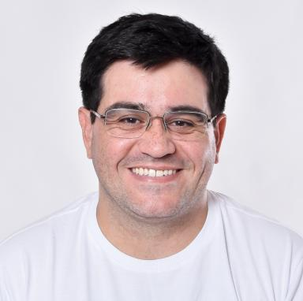 Plácido A. de Souza Neto I'm Full Professor (Professor Titular) at IFRN (Federal Institute of Education, Science and Technology) in Natal-RN, Brazil.

Identifiants chercheurs

- IdHAL : placido-antonio-de-souza-neto
- ORCID : 0000-0003-1233-4510

Présentation

I'm Full Professor (Professor Titular) at IFRN (Federal Institute of Education, Science and Technology) in Natal-RN, Brazil. I held position at Grenoble Alpes University (France) as Post-doctoral fellow between 2014 and 2015. My actual research includes Database Systems, specially on interactive analysis of spatiotemporal data, and Internet of Things. I was Undergraduate Course Coordinator (Analysis and System Development Technology) at IFRN from March 2017 to Abril 2020. I also was Director of Education for the IFRN Natal Central Campus from May 2020, for almost 3 years. I also held position at Orléans University (France) between 2023 and 2024 as Postdoctoral Researcher at Laboratoire d'Informatique Fondamentale d'Orléans (LIFO), Université d'Orléans, in cooperation with LIFAT Laboratoire - Université de Tours and LLL Laboratoire - Université d'Orléans over the domain of Data Science Queries: Language and Algorithms in the context of DOING - APR-IA project.

Publications

Rapport (1)

Predictive Query-based Pipeline for Graph Data
Plácido A Souza Neto
Université d'Orléans (France). 2024
Rapport
hal-04825569v1

Article dans une revue (2)

πSOD-M: Building SOC Applications in the Presence of Non-Functional Requirements
Khalid Belhajjame,Valeria de Castro,Javier A Espinosa-Oviedo,Martin A Musicante,Umberto Souza da Costaet al.
International Journal of Web and Grid Services, 2018, 14 (4), pp.400-431. ⟨10.1504/IJWGS.2018.095660⟩
Article dans une revue
hal-01867030v1
Reliable Web Services Composition: An MDD Approach
Genoveva Vargas-Solar,Valeria de Castro,Placido Antonio Neto Souza,Javier A Espinosa-Oviedo,Esperanza Marcoset al.
Polibits, 2014, 49, pp.17 - 27. ⟨10.17562/PB-49-2⟩
Article dans une revue
hal-01584793v1

Communication dans un congrès (4)

Rhone: a quality-based query rewriting algorithm for data integration.
Daniel A.S. Carvalho,Plácido A. Souza Di Neto,Chirine Ghedira,Nadia Bennani,Genoveva Vargas-Solar
East-European Conference on Advances in Databases and Information Systems, Aug 2016, Prague, Czech Republic. pp.80-87
Communication dans un congrès
hal-01331253v1
Can Data Integration Quality be Enhanced on Multi-cloud using SLA?
Daniel A.S. Carvalho,Placido A. Souza Neto,Genoveva Vargas-Solar,Nadia Bennani,Chirine Ghedira
DEXA 2015, Sep 2015, Valencia, Spain. pp.145-152
Communication dans un congrès
hal-01198495v1
Generating reliable services' composition using A-policies: a model-driven approach
Genoveva Vargas-Solar,Valeria de Castro,Plácido Antonio A Souza Neto,Javier A Espinosa-Oviedo,Esperanza Marcoset al.
the Jornadas de Servicios Web, Sep 2014, Cadiz, Spain
Communication dans un congrès
hal-01584802v1
Supporting Non-functional Requirements in Services Software Development Process: An MDD Approach
Maria Valeria de Castro,Martin A. Musicante,Umberto Souza,Plácido A. Souza Di Neto,Genoveva Vargas-Solar
SOFSEM, Jan 2014, Novy Smokovek, Slovakia. pp.199-210
Communication dans un congrès
hal-01006226v1

