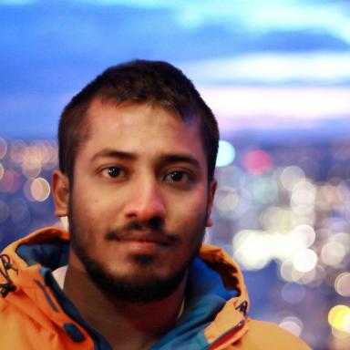 Puneeth Bikkanahally Muni Reddy

Identifiants chercheurs

- IdHAL : puneeth-bikkanahally
- ORCID : 0000-0002-4901-111X
- IdRef : 273314807

Publications

Communication dans un congrès (10)

A modelling strategy for log-layer mismatch in channel ﬂows
Puneeth Bikkanahally,Remi Manceau
THMT 2025 - 11th International Symposium on Turbulence, Heat and Mass Transfer, International Centre for Heat and Mass Transfer (ICHMT); The Heat Transfer Society of Japan (HTSJ), Jul 2025, Tokyo, Japan
Communication dans un congrès
hal-05245470v1
Development of a novel strategy for embedded LES based on continuous hybrid RANS/LES methods
Puneeth Bikkanahally,Remi Manceau
15th Int. ERCOFTAC Symp. on Eng. Turb. Modelling and Measurements, 2025, Dubrovnik, Croatia
Communication dans un congrès
hal-05411500v1
Towards a model for continuous embedded LES (CELES)
Puneeth Bikkanahally,Remi Manceau
CFM 2025 - 26ème Congrès Français de Mécanique, Aug 2025, Metz, France
Communication dans un congrès
hal-05245476v1
Generation of turbulent structures for CELES (continuous embedded LES)
Remi Manceau,Mahitosh Mehta,Martin David,Puneeth Bikkanahally
A turbulence day in celebration of the career of Jean-Paul Bonnet, Institute PPrime, Jun 2024, Poitiers, France
Communication dans un congrès
hal-04620701v1
Modelling turbulent flows in the natural convection regime using hybrid RANS-LES approaches
Puneeth Bikkanahally,Remi Manceau
17th ERCOFTAC SIG15/MONACO2025 workshop: Turbulent natural convection flows in differentially heated cavities, Jan 2023, Pau, France
Communication dans un congrès
hal-03970569v1
Numerical simulation of a turbulent natural convection flow in a cubic cavity with centrally placed partially heated inner obstacle
Sofen Kumar Jena,Puneeth Bikkanahally,Remi Manceau
3rd high-fidelity industrial LES/DNS symp. (HiFiLeD), Dec 2022, Brussels, Belgium
Communication dans un congrès
hal-03928060v1
Development of a hybrid RANS-LES model based on temporal filtering for natural convection flows
Puneeth Bikkanahally,Remi Manceau,Franck Mastrippolito
WCCM - 14th World Congress in Computational Mechanics, ECCOMAS Congress 2020, Jan 2021, Virtual, France. ⟨10.23967/wccm-eccomas.2020.118⟩
Communication dans un congrès
hal-03114394v1
Hybrid Temporal LES: from theory to applications
Remi Manceau,Puneeth Bikkanahally
HiFiLeD - 2nd High Fidelity Industrial LES/DNS Symposium, Sep 2021, Toulouse / Virtual, France
Communication dans un congrès
hal-03366801v1
Modélisation des écoulements turbulents en régime de convection naturelle par approches hybrides RANS-LES
Puneeth Bikkanahally
2021 Journées de l’Ecole Doctorale Sciences Exactes et leurs Applications (ED-SEA), Université de Pau et des Pays de l'Adour (UPPA), Jul 2021, Pau, France
Communication dans un congrès
hal-04933148v1
Modeling turbulent flows in the natural convection regime using hybrid RANS-LES approaches
Puneeth Bikkanahally,Remi Manceau
jspyrene2020 : Journée Scientifique autour du cluster Pyrene et autres moyens de calcul, Oct 2020, Pau, France
Communication dans un congrès
hal-02991109v1

Thèse (1)

Modelling turbulent flows in the natural convection regime using hybrid RANS- LES approaches
Puneeth Bikkanahally Muni Reddy
Mathematics [math]. Université de Pau et des Pays de l'Adour, 2023. English. ⟨NNT : 2023PAUU3069⟩
Thèse
tel-04706508v2

