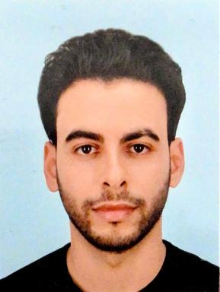 Qacem Khezami PhD Candidate, Aix-Marseille Université, CNRS ESPACE UMR 7300

Identifiants chercheurs

- IdHAL :
qacemkhezami
- ORCID :
0009-0001-5262-0506

Présentation

Research Areas My research focuses on the protection of archaeological heritage from various risks that may affect or destroy it. In particular, it involves the modeling, geosimulation, and mapping of geomorphological hazards related to the evolution of the Nile’s channel and banks, floods, and sedimentation. It also includes the identification and monitoring of anthropogenic risks resulting from territorial transformations and societal dynamics such as demographic growth, urbanization, and agricultural expansion. Furthermore, my work seeks to monitor archaeological sites and detect changes, especially those linked to looting. Beyond these technical aspects, I also explore the collective and geographical construction of spatial memory through the lens of heritage geography in the Sahelian region of Sudan, specifically along the Nile river, in the Middle East, and in restricted areas affected by wars or limited accessibility due to dramatic geography. Geographic Analysis is based on the development and implementation of Earth Observation remote sensing monitoring systems and geo-simulations: multispectral, hyperspectral imagery, artificial intelligence, massive data image processing, multi-temporal geographic knowledge systems, GIS.
Geographic information science
- Remote sensing, image processing, and image analysis
- GIS, spatial modelling, and geo-simulation
- Knowledge models, geographic ontologies, and artificial intelligence
Palimpsest Geography, territorial development, and adaptation of the climate change and globalisation in Sahelian context
- Metropolisation.
- Territorial development and adaption of climate change and globalization.
- Environmental interactions.
- Geopolitical issues.
Geographic areas
- Sahelian region of Sudan.
- Nile River.
- MENA (Middle East and North Africa) region.

Publications

Communication dans un congrès (1)

Innovative monitoring project to protect at risk archaeological heritage in Sudan
Sébastien Poudroux,Qacem Khezami,Juliette Laroye,Séverine Marchi,Sébastien Gadalet al.
SAfA 2025: Crossroads through Time, Society of Africanist Archaeologists (SAfA), Jul 2025, Faro, Portugal, Portugal
Communication dans un congrès
hal-05342212v1

Poster de conférence (1)

Spatialisation et patrimoine au Maghreb : Paysages de centuriation dans la région de Sousse en Tunisie
Sanley Accima,Lune Berana Kassa Kassa,Qacem Khezami,Sébastien Gadal
Assemblée générale Téthys 2025, Jun 2025, Aix-en-Provence, France. , 2025, ⟨10.13140/RG.2.2.36129.93283⟩
Poster de conférence
hal-05127230v1

