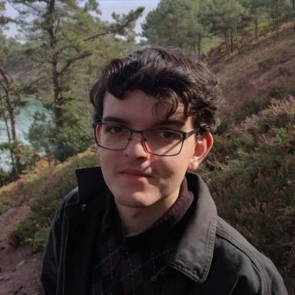 Quentin FAIVRE

Identifiants chercheurs

- IdHAL : quentin-faivre
- ORCID : 0000-0002-9985-5118

Présentation

Publications

Article dans une revue (3)

Spatio-temporal assessment of the polychlorinated biphenyl (PCB) sediment contamination in four major French river corridors (1945-2018)
André-Marie Dendievel,Brice Mourier,Alexandra Coynel,Olivier Evrard,Pierre Labadieet al.
Earth System Science Data, 2020, 12 (2), pp.1153-1170. ⟨10.5194/essd-12-1153-2020⟩
Article dans une revue
cea-02615076v1
Flux estimation, temporal trends and source determination of trace metal contamination in a major tributary of the Seine estuary, France
Thomas Gardes,Maxime Debret,Yoann Copard,Alexandra Coynel,Julien Deloffreet al.
Science of the Total Environment, 2020, 724, pp.138249. ⟨10.1016/j.scitotenv.2020.138249⟩
Article dans une revue
hal-02556187v1
Sediment dynamic equilibrium, a key for assessing a coastal anthropogenic disturbance using geochemical tracers: Application to the eastern part of the Bay of Seine
Noémie Baux,Anne Murat,Quentin Faivre,Sandric Lesourd,Emmanuel Poizotet al.
Continental Shelf Research, 2019, 175, pp.87-98. ⟨10.1016/j.csr.2019.02.002⟩
Article dans une revue
hal-02022702v1

Communication dans un congrès (4)

Reconstruction of long-term water quality trends using sediment databases: insights from a multi-criteria analysis performed on the four main French River Basins (1945 - 2018)
Brice Mourier,André-Marie Dendievel,Olivier Evrard,Alexandra Coynel,Pierre Labadieet al.
CONTASED 2021 (2020 CoV postponed), Jun 2020, Berne, Switzerland
Communication dans un congrès
hal-03837336v1
Assessment of PCB trajectories along French river corridors between 1945 and 2018
André-Marie Dendievel,Brice Mourier,Alexandra Coynel,O. Evrard,Pierre Labadieet al.
EGU General Assembly 2020, May 2020, Vienne, Austria. ⟨10.5194/egusphere-egu2020-2205⟩
Communication dans un congrès
cea-02569277v1
Utilisation de traceurs géochimiques pour étudier la dynamique sédimentaire et l'impact anthropique de dépôts de dragage à proximité d'une zone côtière : exemple en baie de Seine Orientale
Noémie Baux,Anne Murat,Quentin Faivre,Emmanuel Poizot,Yann Méaret al.
26e Réunion des Sciences de la Terre (RST 2018), Oct 2018, Lille, France
Communication dans un congrès
hal-01864589v1
Dynamical equilibrium state, a key to highlight an anthropogenic disturbance: application to the Octeville dredge disposal sediment site (Le Havre harbour, Eastern Bay of Seine)
Noémie Baux,Anne Murat,Quentin Faivre,Emmanuel Poizot,Yann Méaret al.
International Conference on Estuaries and Coasts (ICEC 2018), Aug 2018, Caen, France
Communication dans un congrès
hal-01864584v1

