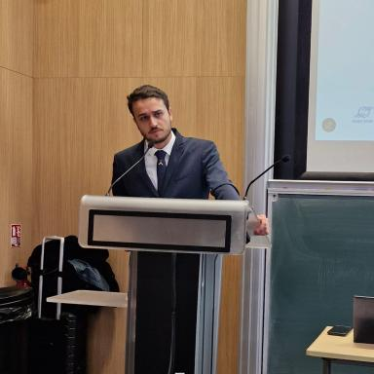 Quentin Raillard--Cazanove

Identifiants chercheurs

- IdHAL : quentin-raillard-cazanove
- ORCID : 0000-0002-4270-9267

Publications

Article dans une revue (4)

Resilience analysis for energy foresight scenarios: addressing the deep uncertainties of hydrogen deployment in industrial hubs
Anaëlle Jodry,Quentin Raillard--Cazanove,Thibaut Knibiehly,Pedro Affonso Nóbrega,Robin Girard
Energy Policy, 2026, 214, pp.115258. ⟨10.1016/j.enpol.2026.115258⟩
Article dans une revue
hal-05564343v1
Decarbonisation of industry and the energy system: Exploring mutual impacts and investment planning
Quentin Raillard--Cazanove,Thibaut Knibiehly,Robin Girard
Journal of Cleaner Production, 2025, 508, pp.145511. ⟨10.1016/j.jclepro.2025.145511⟩
Article dans une revue
hal-05171645v1
Decarbonisation modelling for key industrial sectors focusing on process changes in a cost-optimised pathway
Quentin Raillard--Cazanove,Antoine Rogeau,Robin Girard
Applied Energy, 2025, 382, pp.125206. ⟨10.1016/j.apenergy.2024.125206⟩
Article dans une revue
hal-04882268v1
Analysis of Smart Meter Electricity Consumption Data for PV Storage in the UK
Quentin Raillard-Cazanove,Edward Barbour
Energies, 2022, 15 (10), pp.3732. ⟨10.3390/en15103732⟩
Article dans une revue
hal-04258813v1

Communication dans un congrès (1)

Prospective bottom-up modelling of industry: what place for electrification in a cost optimised trajectory ?
Quentin Raillard-Cazanove,Robin Girard,Antoine Rogeau
2023 IEEE PES Innovative Smart Grid Technologies Conference Europe (ISGT Europe), IEEE, Oct 2023, Grenoble, France
Communication dans un congrès
hal-03750873v1

Pré-publication, Document de travail (1)

Decarbonisation of industry and the energy system: exploring mutual impacts and investment planning
Quentin Raillard--Cazanove,Thibaut Knibiehly,Robin Girard
2024
Pré-publication, Document de travail
hal-04759125v1

