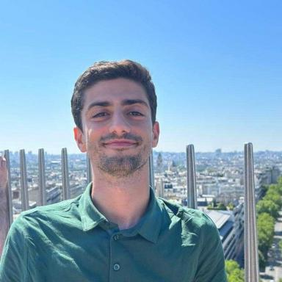 Rafael Silva

Publications

Article dans une revue (1)

Trajectory Tracking Using Quasi-LPV Descriptor Models for Vehicle Control
Mohamed Diouf,Rafael Silva,Thierry Marie Guerra
IFAC-PapersOnLine, 2025, 59 (26), pp.211-216. ⟨10.1016/j.ifacol.2025.12.036⟩
Article dans une revue
hal-05482594v1

Communication dans un congrès (4)

In silico Assessment of Arrhythmia Inducibility Dependence on Stimulus Location using Calibrated MR-based Infarcted Heart Models
Jairo Rodríguez Padilla,Rafael Silva,Buntheng Ly,Graham Wright,Mihaela Popet al.
FIMH 2025 - 13th Functional Imaging and Modeling of the Heart International Conference, Jun 2025, Dallas, United States. ⟨10.1007/978-3-031-94559-5_9⟩
Communication dans un congrès
hal-05119965v1
Frugal AI for Automated Cardiac Defibrillation: Balancing Performance & Hardware Constraints
Rafael Silva,Caroline Stehlé,Guillaume Pétriat,Pierre-Henri Cadet,Thierry Tibiet al.
FIMH 2025 - 13th International Conference on Functional Imaging and Modeling of the Heart, Jun 2025, Dallas (TX), United States. ⟨10.1007/978-3-031-94559-5_14⟩
Communication dans un congrès
hal-05119661v1
YOUR-Lead: YOLO and U-Net for Reconstruction of ECG Lead Signals
Rafael Silva,Yingyu Yang,Maëlis Morier,Safaa Al-Ali,Maxime Sermesant
2024 Computing in Cardiology Conference, Sep 2024, Karlsruhe (Germany), Germany. pp.1-4, ⟨10.22489/CinC.2024.372⟩
Communication dans un congrès
hal-04684731v1
Automatic Analysis of Activation Recovery Interval in Heterogeneous Fibrotic Tissue from Chronically Infarcted Swine
Rafael Silva,Jairo Rodríguez-Padilla,Mihaela Pop,Maxime Sermesant
CinC 2024 - 51th International Computing in Cardiology 2024, Sep 2024, Karlsruhe, Germany. ⟨10.22489/CinC.2024.417⟩
Communication dans un congrès
hal-04693691v2

Poster de conférence (3)

Frugal AI for Automated Cardiac Defibrillation: Balancing Performance & Hardware Constraints
Rafael Silva,Caroline Stehlé,Maxime Sermesant,Guillaume Pétriat,Pierre-Henri Cadetet al.
FIMH 2025 - 13th International Conference on Functional Imaging and Modeling of the Heart, Jun 2025, Dallas (TX), United States. , Lecture notes in computer science, LNCS-15672, Functional Imaging and Modeling of the Heart
Poster de conférence
hal-05119662v1
Activation Recovery Interval for Personalized Cardiac Assessment
Rafael Silva,Jairo Rodríguez-Padilla,Mihaela Pop,Maxime Sermesant
CinC 2024 - (&th international Computing in Cardiology, Sep 2024, Karlsruhe, Germany. Zenodo, Computing in Cardiology 2024, 2024, ⟨10.5281/zenodo.13741173⟩
Poster de conférence
hal-04871966v1
Artificial Intelligence for Automated Cardiac Defibrillation in Embedded Systems
Rafael Silva,Caroline Stehlé,Maxime Sermesant
SophIA Summit 2024, Nov 2024, Biot, France. Zenodo, 2024, ⟨10.5281/zenodo.14251333⟩
Poster de conférence
hal-04871976v1

