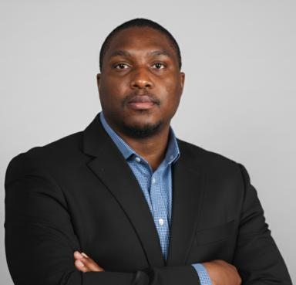 Raphael Onuku

Identifiants chercheurs

- IdHAL : raphael-onuku
- ORCID : 0000-0003-2564-2109
- cv.identifier.google scholar : https://scholar.google.fr/citations?user=BeNWFb0AAAAJ

Publications

Article dans une revue (8)

Contribution of Prostaglandin E2‐Induced Neuronal Excitation to Drug Resistance in Glioblastoma Countered by a Novel Blood–Brain Barrier Crossing Celecoxib Derivative
Chih‐jie Shen,Hsien‐chung Chen,Chien‐liang Lin,Amandeep Thakur,Raphael Onukuet al.
Advanced Science, 2025, 12 (38), ⟨10.1002/advs.202506336⟩
Article dans une revue
hal-05341265v1
Scaffold hopping approaches for dual-target antitumor drug discovery: opportunities and challenges
Anshul Mishra,Amandeep Thakur,Ram Sharma,Raphael Onuku,Charanjit Kauret al.
Expert Opinion on Drug Discovery, 2024, 19 (11), pp.1355-1381. ⟨10.1080/17460441.2024.2409674⟩
Article dans une revue
hal-05341267v1
The International Natural Product Sciences Taskforce (INPST) and the power of Twitter networking exemplified through #INPST hashtag analysis
Rajeev K. Singla,Ronita De,Thomas Efferth,Bruno Mezzetti,M. D. Sahab Uddinet al.
Phytomedicine, 2022, 108, pp.154520. ⟨10.1016/j.phymed.2022.154520⟩
Article dans une revue
hal-03994795v1
New sulphonamide-peptide hybrid molecules as potential PBP 2a ligands and methicillin resistant Staphylococcus aureus actives
Akachukwu Ibezim,Raphael Onuku,Chidalu Ottih,Ifeoma Ezeonu,Efeturi Onoabedjeet al.
Journal of Biomolecular Structure and Dynamics, 2022, 41 (14), pp.6684-6694. ⟨10.1080/07391102.2022.2111359⟩
Article dans une revue
hal-04629642v1
Chemical constituents of Combretum dolichopetalum: Characterization, antitrypanosomal activities and molecular docking studies
Charles Nnadi,Raphael Onuku,Thecla Ayoka,Ndidiamaka Okorie,Ngozi Nwodo
Tropical Journal of Pharmaceutical Research, 2022, 21 (4), pp.801-808. ⟨10.4314/tjpr.v21i4.17⟩
Article dans une revue
hal-04629644v1
Incorporating Cryopreservation Evaluations Into the Design of Cell-Based Drug Delivery Systems: An Opinion Paper
Marlene Davis Ekpo,Jingxian Xie,Xiangjian Liu,Raphael Onuku,George Frimpong Boafoet al.
Frontiers in Immunology, 2022, 13, ⟨10.3389/fimmu.2022.967731⟩
Article dans une revue
hal-04629656v1
Computational Applications in Secondary Metabolite Discovery (CAiSMD): an online workshop
Fidele Ntie-Kang,Kiran Telukunta,Serge Fobofou,Victor Chukwudi Osamor,Samuel Egieyehet al.
Journal of Cheminformatics, 2021, 13 (1), pp.64. ⟨10.1186/s13321-021-00546-8⟩
Article dans une revue
hal-04629646v1
Structure-based virtual screening and molecular dynamics simulation studies to discover new SARS-CoV-2 main protease inhibitors
A. Ibezim,Raphael Onuku,A. Ibezim,F. Ntie-Kang,N.J. Nwodoet al.
Scientific African, 2021, 14, pp.e00970. ⟨10.1016/j.sciaf.2021.e00970⟩
Article dans une revue
hal-04629648v1

Autre publication scientifique (1)

Tutorial: How to Use OpenBabel Software to Split Molecules in .sdf File Format or in More Compressed Formats
Raphael Onuku
2019, ⟨10.13140/RG.2.2.35928.62722⟩
Autre publication scientifique
hal-04629658v1

