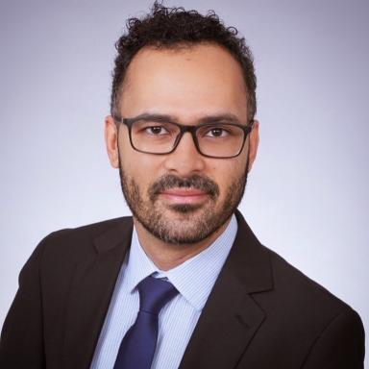 Mendes Rafael Gregorio Tenure track researcherICMN, CNRS – Interfaces, Confinement, Materials and Nanostructures, Orléans, France

Présentation

I am fascinated by the potential to use electron beams to probe new nanomaterials by investigating their growth and degradation at the atomic scale. My interests include characterization and atomic manipulation of 2D nanostructured materials using transmission electron microscopy, namely electron beam as a tool to probe and engineer materials at the nanoscale.

Publications

Article dans une revue (5)

In Situ Growth of Suspended Zirconene Islets Inside Graphene Pores
Rafael Mendes,Huy Quang Ta,Thomas Gemming,Heleen van Gog,Marijn van Huiset al.
Advanced Functional Materials, 2025, 35 (2), pp.2412889. ⟨10.1002/adfm.202412889⟩
Article dans une revue
hal-05409071v1
Probing Ion Diffusion and Ion Sieving through Hollow Porous Silica Shells by Imaging the Mobility of Colloids Inside the Shells
Kanako Watanabe,Tom Welling,Rafael Mendes,Zahra Peimanifard,Maarten Bransenet al.
Advanced Materials Interfaces, 2024, 11 (29), ⟨10.1002/admi.202400333⟩
Article dans une revue
hal-05409062v1
Characterization of the Edge States in Colloidal Bi&lt;sub&gt;2&lt;/sub&gt;Se&lt;sub&gt;3&lt;/sub&gt; Platelets
Jesper R Moes,Jara F Vliem,Pedro M M C de Melo,Thomas C Wigmans,Andrés R Botello-Méndezet al.
Nano Letters, 2024, 24 (17), pp.5110 - 5116. ⟨10.1021/acs.nanolett.3c04460⟩
Article dans une revue
hal-04575158v2
Unraveling the Formation of Ternary AgCuSe Crystalline Nanophases and Their Potential as Antibacterial Agents
Mengxi Lin,Beatriz Vargas,Lluís Yedra,Heleen van Gog,Marijn van Huiset al.
Chemistry of Materials, 2024, 36 (20), pp.10154-10166. ⟨10.1021/acs.chemmater.4c01604⟩
Article dans une revue
hal-05411349v1
Anchoring PdOx clusters on defective alumina for improved catalytic methane oxidation
Xiang Yu,Nina Genz,Rafael Mendes,Xinwei Ye,Florian Meireret al.
Nature Communications, 2024, 15 (1), pp.6494. ⟨10.1038/s41467-024-50216-0⟩
Article dans une revue
hal-05409056v1

