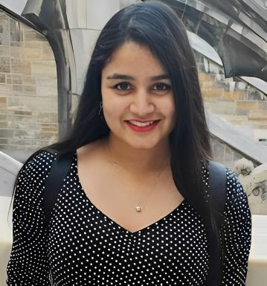 Riddhi Kumari Riddhi

Identifiants chercheurs

- IdHAL : riddhi-kumari-riddhi

Publications

Communication dans un congrès (4)

Molecular Understanding of Heterogeneous Organometallic Photocatalyst
R. Kumari,Wisser F. M.,J. Canivet,E. Quadrelli
18th ICC - International Congress on Catalysis, Jul 2024, Lyon, France
Communication dans un congrès
hal-04675487v1
HETEROGENIZED MOLECULAR PHOTOCATALYSIS FOR CO2 TO FORMIC ACID CONVERSION USING VISIBLE LIGHT
R. Kumari,J. Canivet,E. Quadrelli
Journées communes aux GdR Solar Fuels et Photo Electro Stimulation, Jun 2024, Grenoble, France
Communication dans un congrès
hal-04630660v1
Heterogenized Molecular Photocatalysis for CO2 to Formic Acid Conversion Using Visible Light
R. Kumari,J. Canivet,E. Quadrelli
2024 French MOFs, COFs and Porous Polymers Conference, Jun 2024, Villeurbanne, France
Communication dans un congrès
hal-04612071v1
MOF-based Molecular Catalysts for the Light-Driven Conversion of Carbon Dioxide
J. Canivet,E. Quadrelli,R. Kumari,A. Ranscht,F.M. Wisseret al.
5th European Conference on Metal Organic Frameworks and Porous Polymers (EuroMOF2023), Sep 2023, Granada, Spain
Communication dans un congrès
hal-04229740v1

