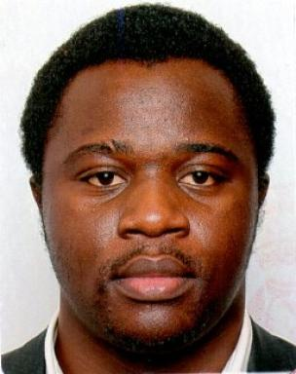 Rodrigue FOKOUOP Senior Operation Research & Decision Scientist, Air Liquide International Expert

Présentation

Short Bio:2023 - Ph.D. in Industrial Engineering, LGI - CentraleSupelec, Paris-Saclay University
2014 - Master’s degree in Optimization of Industrial and Logistic Systems, ́Ecole Centrale Paris
2013 - Industrial engineer degree, option: supply chain management, Grenoble INP - G ́enie industriel, DualDegree with NASE
2013 - Industrial engineer degree, National Advanced School of Engineering of Yaound ́e (NASE), Cameroon
2010 - Master’s Degree in Applied Mathematics, option: mathematical modeling and dynamic systems, Faculty of Sciences, University of Yaoundé 1, Cameroon
Business domains:Logistics & Supply Chain, Gas Distribution, Healthcare Delivery Systems
Scientific skills:Modeling and Mathematical Programming, Simulation, Stochastic Optimization,Combinatorial Optimization, Decomposition Techniques, Dynamic Programming, Meta-heuristics
Functional skills:Resources Optimization, Decision Support, Software Engineering, Process Improvement, Innovation, Curiosity towards business and operations research topics, Business Analysis

Publications

Communication dans un congrès (2)

Simulation-optimization of an inventory control policy in a distribution multi-echelon system with returns
Rodrigue Fokouop,Zied Jemai,Evren Sahin,Yves Dallery
CIGI Qualita MOSIM 2023, Jun 2023, Trois Rivières (Québec), Canada. pp.2992-2997
Communication dans un congrès
hal-04430389v1
Multi-echelon inventory optimization in closed-loop supply chain
Rodrigue Fokouop,Z Jemai,E Sahin,Y Dallery
MIM 2022, Jun 2022, Nantes, France. pp.2992-2997, ⟨10.1016/j.ifacol.2022.10.187⟩
Communication dans un congrès
hal-04430397v1

Article dans une revue (1)

A heuristic approach for multi-echelon inventory optimisation in a closed-loop supply chain
Rodrigue Fokouop,Evren Sahin,Zied Jemai,Yves Dallery
International Journal of Production Research, 2023, 69 (10), pp.3435-3459. ⟨10.1080/00207543.2023.2239393⟩
Article dans une revue
hal-04330901v1

