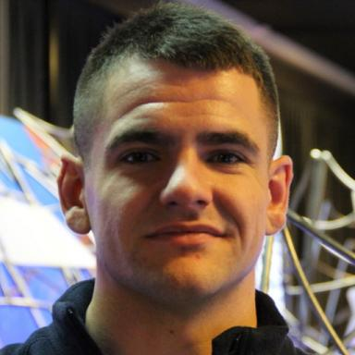 Romain TABUSSE

Identifiants chercheurs

- IdHAL : romain-tabusse
- ORCID : 0000-0002-2862-5518

Publications

Article dans une revue (1)

Aging Study of In-Use Lithium-Ion Battery Packs to Predict End of Life Using Black Box Model
Daniela Chrenko,Manuel Fernandez Montejano,Sudnya Harishchandra Vaidya,Romain Tabusse
Applied Sciences, 2022, 12 (13), pp.6557 (27). ⟨10.3390/app12136557⟩
Article dans une revue
hal-03783379v1

Communication dans un congrès (5)

Autonomous Electric Vehicle Routing Problem using Ant Colony Optimization with consideration of the Battery State-of-Health
Pierre Romet,Romain Tabusse,Franck Gechter,El-Hassane Aglzim,Samir Jemeiet al.
2021 IEEE 33rd International Conference on Tools with Artificial Intelligence (ICTAI), Nov 2021, Washington, United States. pp.475-480, ⟨10.1109/ICTAI52525.2021.00077⟩
Communication dans un congrès
hal-03549351v1
Tournée de Véhicule électrique et prise en compte du vieillissement des batteries
Pierre Romet,Romain Tabusse,Franck Gechter,El Hassane Aglzim,Samir Jemeïet al.
FuturMob 2021, Oct 2021, Nevers, France
Communication dans un congrès
hal-03554337v1
Characterizing Aging of Lithium-ion Batteries during Long-term Test Campaigns for Transport Applications
Romain Tabusse,Daniela Chrenko,Samir Jemei,Daniel Hissel,David Bouquainet al.
International Conference on Ecological Vehicles and Renewable Energies, May 2021, Monte-Carlo, Monaco
Communication dans un congrès
hal-03359930v1
Study of lithium-ion battery ageing cycled with current profiles from railway applications
Charles Lorenzo,Romain Tabusse,David Bouquain,Samuel Hibon,Daniel Hissel
IEEE Conference on Vehicle Power and Propulsion (VPPC) 2021, Oct 2021, Gijon, Spain
Communication dans un congrès
hal-03814540v1
Battery aging test design during first and second life
Romain Tabusse,David Bouquain,Samir Jemei,Daniela Chrenko
Vehicle Power and Propulsion Conference, Nov 2020, Gijon, Spain
Communication dans un congrès
hal-03186613v1

