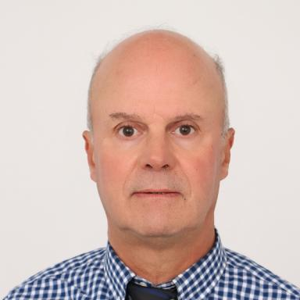 Said Slaoui Professor at Mohammed V University in Rabat.

Identifiants chercheurs

- IdHAL : said-slaoui
- ORCID : 0009-0001-6900-8102

Présentation

Said Slaoui is a professor at Mohammed V University in Rabat, Morocco. He graduated in Computer Science from University Pierre and Marie Curie, Paris VI (in collaboration with IBM France), 1986. He has over 40 years of experience in the fields of AI and Big Data, with research focused on modular architectures, symbolic reasoning, and computational frugality. His recent work introduces the Sparse Artificial Intelligence (S-AI) framework, which integrates bio-inspired signaling and agent-based orchestration. He has published numerous scientific papers in international journals and conferences, and actively contributes to the development of sustainable and explainable AI systems.

Publications

Article dans une revue (2)

S-AI-AntiHallucination: A Bio-Inspired and Confidence-Aware Sparse AI Framework for Reliable Generative Systems
Slaoui Said
International Journal of Artificial Intelligence & Applications (IJAIA), 2025, 16 (6), pp.1-25
Article dans une revue
hal-05389241v1
Calcul des partitions optimales d'un critère d'adéquation à une préordonnance.
Said Slaoui Chah
Annales de l'ISUP, 1984
Article dans une revue
halshs-05456696v1

Pré-publication, Document de travail (1)

From Hormones to Probabilities: A Unified Doctrine of Cognitive Homeostasis in Sparse Artificial Intelligence (S-AI)
Said Slaoui
2025
Pré-publication, Document de travail
hal-05359348v1

