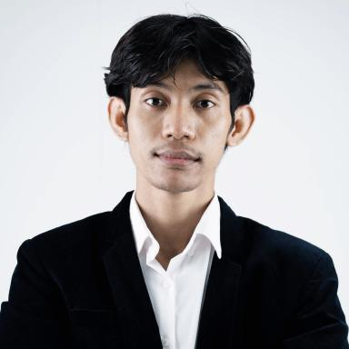 Saly KEO

Identifiants chercheurs

- IdHAL : salykeo
- ORCID : 0009-0000-9878-4015
- cv.identifier.google scholar : https://scholar.google.fr/citations?user=78TuKksAAAAJ

Publications

Communication dans un congrès (4)

Cross-Lingual Learning for Low-Resource Khmer Scene Text Detection and Recognition
Vannkinh Nom,Saly Keo,Souhail Bakkali,Muhammad Muzzamil Luqman,Mickaël Coustatyet al.
ICDAR 2025 Workshop on Documents Analysis of Low-resource Languages, Sep 2025, Wuhan, Hubei, China
Communication dans un congrès
hal-05191219v1
WildKhmerST: A Comprehensive Dataset and Benchmark for Khmer Scene Text Detection and Recognition in the Wild
Vannkinh Nom,Saly Keo,Souhail Bakkali,Muhammad Muzzamil Luqman,Mickaël Coustatyet al.
The 19th International Conference on Document Analysis and Recognition, Sep 2025, Wuhan, Hubei, China
Communication dans un congrès
hal-05120511v1
Visual Text Generation in Khmer Language: Challenges and Trends with Diffusion Models
Saly Keo,Vannkinh Nom,Souhail Bakkali,Muhammad Muzzamil Luqman,Mickaël Coustatyet al.
The 19th International Conference on Document Analysis and Recognition, Sep 2025, Wuhan China, China
Communication dans un congrès
hal-05178406v2
State-of-the-Art Khmer Text Recognition Using Deep Learning Models
Saly Keo,Mickaël Coustaty,Souhail Bakkali,Marçal Rossinyol
ASEAN Conference on Emerging Technologies 2024, Nov 2024, PHNO PENH, Cambodia
Communication dans un congrès
hal-05157225v1

