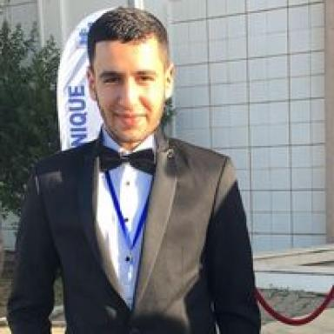 Sameh Mabrouki

Identifiants chercheurs

- IdHAL : sameh-mabrouki
- IdRef : 292614322

Présentation

Publications

Article dans une revue (2)

Millimetric waves communications for Railways
Marion Berbineau,Nicholas Attwood,François Gallée,Patrice Pajusco,Qianrui Liet al.
Transportation Research Procedia, 2023, 72, pp.1248-1255. ⟨10.1016/j.trpro.2023.11.584⟩
Article dans une revue
hal-04434496v1
Codebook Designs for Millimeter-Wave Communication Systems in Both Lowand High-Mobility: Achievements and Challenges
Semah Mabrouki,Iyad Dayoub,Qianrui Li,Marion Berbineau
IEEE Access, 2022, 10, pp.25786 - 25810. ⟨10.1109/ACCESS.2022.3154016⟩
Article dans une revue
hal-03595846v1

Communication dans un congrès (4)

Comparative Study of Real-Time Beamforming Techniques for Railway Communication Systems in LoS and NLoS Scenarios
Semah Mabrouki,Iyad Dayoub,Marion Berbineau
2025 19th European Conference on Antennas and Propagation (EuCAP), Mar 2025, Stockholm, Denmark. pp.1-5, ⟨10.23919/EuCAP63536.2025.10999481⟩
Communication dans un congrès
hal-05150793v1
Smart Beamforming for High Mobility Millimeter-Wave Train-to-Infrastructure Networks: A Machine Learning Approach
Semah Mabrouki,Iyad Dayoub,Marion Berbineau
2024 IEEE Canadian Conference on Electrical and Computer Engineering (CCECE), Aug 2024, Kingston, Canada. pp.746-752, ⟨10.1109/CCECE59415.2024.10667240⟩
Communication dans un congrès
hal-04698453v1
On The Performance Of Beamforming Techniques Based On 3D Predefined Codebook Designs In 3GPP Mobile Communication Systems
Semah Mabrouki,Iyad Dayoub,Marion Berbineau
2023 IEEE Third International Conference on Signal, Control and Communication (SCC), Dec 2023, Hammamet, Tunisia. pp.01-06, ⟨10.1109/SCC59637.2023.10527751⟩
Communication dans un congrès
hal-04580120v1
Millimetric-Waves communication for Railways
Marion Berbineau,Nicholas Attwood,François Gallée,Patrice Pajusco,Qianrui Liet al.
9th Transport Research Arena TRA Lisbon 2022, Nov 2022, Lisbon, Portugal
Communication dans un congrès
hal-04106265v1

Thèse (1)

Study and design of codebooks for medium and high mobility millimetric communications systems
Semah Mabrouki
Signal and Image Processing. Université Polytechnique Hauts-de-France; Institut national des sciences appliquées Hauts-de-France, 2025. English. ⟨NNT : 2025UPHF0013⟩
Thèse
tel-05246904v1

