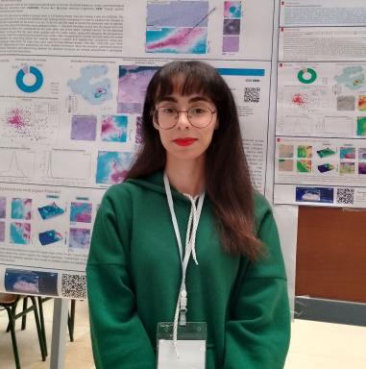 Samira Yalla

Identifiants chercheurs

- IdHAL : samira-yalla
- ORCID : 0009-0000-4369-3693

Publications

Poster de conférence (2)

GIS and remote sensing contribution to the detection of structural features: A case study on circular geological structures in Algeria
Samira Yalla,Moulley Charaf Chabou,David Baratoux
International Symposium on Seismic Risk, Urbanization, and REsilience in the Western MEDiterranean (SURE-MED), Oct 2025, Constantine, Algeria. 2025, ⟨10.13140/RG.2.2.34221.76001⟩
Poster de conférence
hal-05367412v1
Systematic approach using FABDEMs and satellite imagery to inventory circular structures and identify new potential impact craters in Algeria.
Samira Yalla,Moulley Charaf Chabou,David Baratoux
Colloque National des Doctorants et des Chercheurs en Géoscience (CNDCG), USTHB., Dec 2024, Algiers, Algeria. ⟨10.13140/RG.2.2.35467.40485⟩
Poster de conférence
hal-04823932v1

