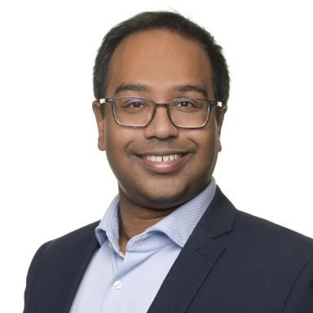 Sandeep Kumar Scientific Employee at Fraunhofer ITWM

Identifiants chercheurs

- IdHAL : sandeep-kumar
- ORCID : 0000-0002-4679-8367

Présentation

Sandeep Kumar is working as a Software Developer at Fraunhofer ITWM. He is currently working on projects, such as, FPGA-based HPC systems, melt flow simulation for sealing process in packaging industry using the MESHFREE software, GUI development for interactive use of our software, etc. He graduated from Leibniz Universität Hannover with a Ph.D. degree in Mechanical Engineering in 2022. His doctoral work was within the framework of International Doctoral Programme (ViVaCE: Virtual Materials and their Validation- German-French School of Computational Engineering) and he was a visiting researcher at ENS Paris-Saclay (Paris, France) and Université de Lille (Lille, France). He has a Master Degree and Bachelor Degree in Mechanical Engineering from IIT Guwahati (2015) and KIIT University (2013) respectively.
His research interests are multidisciplinary: Parallel Computing, Computational Mechanics, Numerical Modeling and Simulation.

Publications

Article dans une revue (1)

Parallel multiphysics simulation for the stabilized Optimal Transportation Meshfree (OTM) method
Sandeep Kumar,Pierre Gosselet,Dengpeng Huang,Christian Weißenfels,Peter Wriggers
Journal of computational science, 2022, 62, pp.101739. ⟨10.1016/j.jocs.2022.101739⟩
Article dans une revue
hal-03699096v1

Communication dans un congrès (1)

Parallel High Performance Simulation for the Stabilized Optimal Transportation Meshfree Method
Sandeep Kumar,Christian Weissenfels,Pierre Gosselet,Peter Wriggers
6th European Conference on Computational Mechanics (ECCM 6), Jun 2018, Glasgow, United Kingdom
Communication dans un congrès
hal-01899879v1

Thèse (1)

High Performance Computing for Modelling of Stereolithography Process
Sandeep Kumar
Computer Science [cs]. Leibniz Universität Hannover, 2022. English. ⟨NNT : ⟩
Thèse
tel-04058904v1

