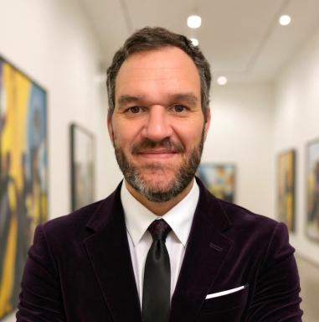 Mario Santos López

Identifiants chercheurs

- IdHAL : santos-lopez-mario
- ORCID : 0009-0003-9973-1128
- ISNI : 0000000528730838
- ResearcherID : OQL-3558-2025

Présentation

Historian specialising in cultural heritage, with research interests in genealogy and court portraiture. My work explores the intersections between visual traditions, noble lineages, and cultural memory in early modern Europe.

Publications

Ouvrages (2)

Corte e Imagen: la Monarquía Hispánica a través del retrato
Mario Santos López
Independently published, 2025, 9798267215862. ⟨10.5281/zenodo.17288292⟩
Ouvrages (ouvrage de synthèse)
hal-05344556v1
El Linaje y la Lanza: Historia del Linaje Duque
Mario Santos López
Independently published, 2025, 9798294244170. ⟨10.5281/zenodo.17287870⟩
Ouvrages (ouvrage de synthèse)
hal-05344468v1

Autre publication scientifique (5)

Oath, lineage, and return: a letter from Las Charcas (1580) by Gonzalo de Ribas Valdés to his father in Oviedo
Mario Santos López
2026, pp.1-12. ⟨10.5281/zenodo.18212395⟩
Autre publication scientifique
hal-05452626v1
Ejecutoria de Hidalguía en Castilla (1571)
Mario Santos López
2025, pp.1-10. ⟨10.5281/zenodo.17454817⟩
Autre publication scientifique
hal-05353190v1
Letter of Nobility in Castile (1571)
Mario Santos López
2025, pp.10. ⟨10.5281/zenodo.17462757⟩
Autre publication scientifique
hal-05344751v1
The Levant Armada in 1588: Three Letters to Philip II
Mario Santos López
2025, pp.1-16. ⟨10.5281/zenodo.17512086⟩
Autre publication scientifique
hal-05344813v1
Memory and Notarial Practice: A Reading of Legajo 7055/2 (Burgos, 1771)
Mario Santos López
2025, pp.20. ⟨10.5281/zenodo.17483203⟩
Autre publication scientifique
hal-05344783v1

Thèse (1)

Los retratos de la familia de Felipe IV en Hampton Court. Estado de la cuestión
Mario Santos López
Humanities and Social Sciences. Universidad de Burgos, 2019. Español. ⟨NNT : ⟩
Thèse
tel-05344688v1

