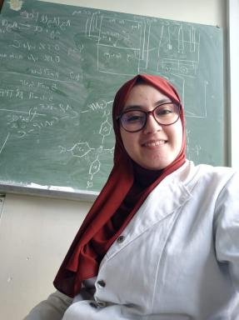 SARA EL HOUBBADI Phd student...To be continue

Identifiants chercheurs

- IdHAL : sara-el-houbbadi
- ORCID : 0000-0003-4846-9281

Présentation

My current position as a PhD student at the Institute of Nuclear Physics and Lorraine University has taught me to be a resourceful and proactive team member. Working on diverse tasks within my research group has helped me develop into a versatile and goal-oriented individual. This experience has strengthened my ability to approach problems from different angles and levels of complexity, while continuously fulfilling my curiosity and eagerness to broaden my knowledge

Publications

Article dans une revue (1)

Revealing the molecular structure of copper phosphonate groups anchored inside SBA-15 silica channels: Theoretical and experimental study
Sara El Houbbadi,Magdalena Laskowska,Alain Walcarius,Marek Doskocz,Alexey Maximenkoet al.
Applied Surface Science, 2024, 669, pp.160425. ⟨10.1016/j.apsusc.2024.160425⟩
Article dans une revue
hal-05072301v1

Communication dans un congrès (2)

Revealing the true configuration of copper phosphonate units inside silica pores with X-ray Absorption Spectroscopy
Sara El Houbbadi,Magdalena Laskowska,Alain Walcarius,Łukasz Laskowski
OPERA COST Action Workshop “European Workshop on Innovative and Advanced Epitaxy”, Jun 2024, Vilnius, Lithuania
Communication dans un congrès
hal-04728531v1
Experimental and Theoretical XAFS studies of the atomic structure of Copper functionalized SBA-15 mesoporous matrix
Sara El Houbbadi,Magdalena Laskowska,Łukasz Laskowski
Young Multis 2023 – Multiscale Phenomena in Condensed Matter, a conference for young researchers, Jul 2023, Kraków, Poland
Communication dans un congrès
hal-04728606v1

