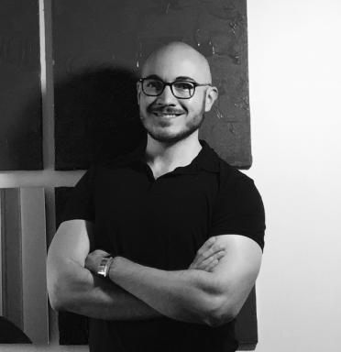 Saulo Santos

Identifiants chercheurs

- IdHAL : saulo-santos
- ORCID : 0000-0002-9399-9241
- IdRef : 278527329

Présentation

Bachelor's degree in Law (FEAD/2015) and in Literature/Linguistics (UFMG/2017), Master's degree in Theoretical and Descriptive Linguistics (UFMG/2020). Currently doing a PhD in international co-supervisor in Linguistics, by the Postgraduate Program in Linguistic Studies (PosLin) of the Faculty of Letters of UFMG (POSLIN/FALE/UFMG), and Computer Sciences, by the Doctoral School of Information and Communication Sciences and Technologies at the University of Paris-Saclay (ED STIC/UPSaclay).

Publications

Chapitre d'ouvrage (2)

Defining and Identifying Discourse Markers in Spontaneous Speech
Tommaso Raso,Saulo Mendes Santos,Albert Rilliard,João A. Moraes
Miguel Oliveira, Jr. Prosodic Interfaces - Interdisciplinary Perspectives on Sound Patterns and Human Interaction, De Gruyter, pp.65-102, 2025, 978-3-11-105990-7. ⟨10.1515/9783111060309-003⟩
Chapitre d'ouvrage
hal-05230528v1
A Protocol for Comparing Gesture and Prosodic Boundaries in Multimodal Corpora
Camila Barros,Saulo Santos
Computational Processing of the Portuguese Language, 13208, Springer International Publishing, pp.313-322, 2022, Lecture Notes in Computer Science, ⟨10.1007/978-3-030-98305-5_29⟩
Chapitre d'ouvrage
hal-04401896v1

Thèse (1)

How to deal with Discourse Markers : a prosodic, corpus-based, computational and experimental proposal
Saulo Mendes Santos
Computation and Language [cs.CL]. Université Paris-Saclay; Universidade Federal de Minas Gerais, 2024. English. ⟨NNT : 2024UPASG013⟩
Thèse
tel-04594427v1

Communication dans un congrès (1)

Discourse Markers as information units formally conveyed by prosody
Tommaso Raso,Albert Rilliard,Saulo Mendes Santos,João Antônio De Moraes
Discourse Markers - Theories and Methods, Laure Lansari; Ludivine Crible, May 2023, Paris, France
Communication dans un congrès
hal-04359874v1

Article dans une revue (3)

Modeling the prosodic forms of Discourse Markers
Tommaso Raso,Albert Rilliard,Saulo Mendes Santos
Domínios de Lingu@gem, 2022, 16 (4), pp.1436-1488. ⟨10.14393/DL52-v16n4a2022-8⟩
Article dans une revue
hal-03775659v1
Short information units
Tommaso Raso,Saulo Santos
Journal of Speech Sciences, 2020, 8 (2), pp.03-35. ⟨10.20396/joss.v8i2.14994⟩
Article dans une revue
hal-04401898v1
Ongoing Grammaticalization Process of the Lexeme &quot;Tipo&quot; A Study Based on a Spontaneous Speech Corpus of Brazilian Portuguese
Saulo Santos
Revista Inventário, 2019, 23, pp.207-226
Article dans une revue
hal-04401899v1

