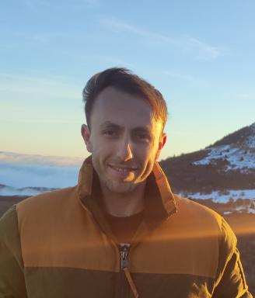 Sébastien AUTRET PhD student in microbial ecology

Publications

Communication dans un congrès (2)

Assessment of the cyanobacterial risk linked to the presence of Pectinatella magnifica
Sébastien Autret,Françoise Girardot
E-Tox 2025, GdR Phycotox; GIS Cyanobactéries, May 2025, Cestas, France
Communication dans un congrès
hal-05107605v1
Monitoring of cyanobacteria populations in the Lake of Devesset
Sébastien Autret,Françoise Girardot
GIS Cyanobactéries 2023, GdR Phycotox, May 2023, Nantes, France
Communication dans un congrès
hal-04918567v1

Poster de conférence (1)

Assessment of the cyanobacteria risk, considering the invasive bryozoan Pectinatella magnifica : methodological approach
Sébastien Autret,Maria Ines Moreira de Gouveia,Audrey Vanhove,Séverine Allegra,Françoise Girardot
AquaEcOmics, Mar 2025, Evian les Bains, France. , 2025, ⟨10.57745/VBSHUO⟩
Poster de conférence
hal-05004222v1

Article dans une revue (1)

A new case of Kaufman Oculocerebrofacial Syndrome caused by two new splicing variants in UBE3B.
K. Uguen,C. Ka,M. Planes,S. Audebert-Bellanger,S. Redonet al.
European Journal of Human Genetics, 2020, 28 (SUPPL 1), pp.366-367
Article dans une revue
hal-03131644v1

