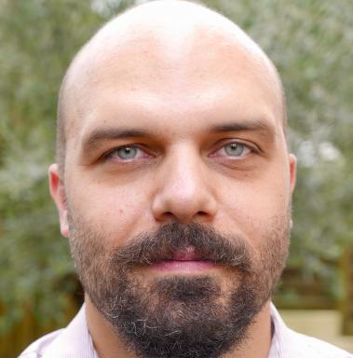 Sébastien Metz

Identifiants chercheurs

- IdHAL : sebmetz
- ORCID : 0000-0003-4216-4583

Publications

Article dans une revue (3)

Brexit and Fisheries: A Question of Conflicting Expectations
Bertrand Le Gallic,Simon Mardle,Sébastien Metz
EuroChoices, 2018, 17 (2), pp.30-37. ⟨10.1111/1746-692X.12200⟩
Article dans une revue
hal-01939776v1
Identification of the main exposure scenarios in the production of CNT-polymer nanocomposites by melt-moulding process
Dominique Fleury,Joao A.S. Bomfim,Alexis Vignes,Clément Girard,Sébastien Metzet al.
Journal of Cleaner Production, 2013, 53, pp.22-36. ⟨10.1016/j.jclepro.2011.11.009⟩
Article dans une revue
istex
ineris-00963427v1
Nanoparticle risk management and cost evaluation : a general framework
Dominique Fleury,Joao A.S. Bomfim,Sébastien Metz,Jacques Bouillard,Jean-Marc Brignon
Journal of Physics: Conference Series, 2011, 304, pp.art 012084. ⟨10.1088/1742-6596/304/1/012084⟩
Article dans une revue
ineris-00963302v1

Communication dans un congrès (3)

Brexit and Seafood Trade: key lessons learned so far
Sébastien Metz,B. Le Gallic,S. Mardle
EAFE 2019, Santiago de Compostella, University of Santiago de Compostela, European Association of Fisheries Economists, Apr 2019, Santiago de Compostela, Spain. ⟨10.13140/RG.2.2.16110.66889⟩
Communication dans un congrès
hal-04199021v1
Nanoparticle risk management and cost evaluation : a general framework
Dominique Fleury,Sébastien Metz,Joao A.S. Bomfim,Jacques Bouillard,Jean-Marc Brignon
International Conference on Safe Production and Use of Nanomaterials (NANOSAFE 2010), Nov 2010, Grenoble, France
Communication dans un congrès
ineris-00970699v1
Socio-economic analysis : a tool for regulating nanotechnologies
Jean-Marc Brignon,Sébastien Metz
International Conference on Safe Production and Use of Nanomaterials (NANOSAFE 2010), Nov 2010, Grenoble, France
Communication dans un congrès
ineris-00970694v1

Rapport (2)

Workshop on the European Green Deal -Challenges and opportunities for EU fisheries and aquaculture Part II: Marine biodiversity aspects
Sébastien Metz,Joachim Claudet
European Commission. 2023, https://bit.ly/3Q1uGjo
Rapport
hal-05307404v1
TITAN Project Deliverable 5.1 – Plan for synergistic work of sustainability pilots
Bernadette Durand,Pascal Neveu,Kirsten Coppoolse,Sébastien Metz,Hoang-Nam Voet al.
TITAN Project. 2023
Rapport
hal-04588222v1

