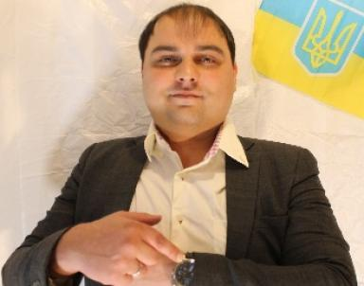 Serhii Kharchuk

Identifiants chercheurs

- IdHAL : serhii-kharchuk
- ORCID : 0009-0003-6531-4692
- ISNI : 0000000526483861
- ResearcherID : KEH-9362-2024

Publications

Pré-publication, Document de travail (5)

From Classical Neurophysiology to Quantum Synchronization: A New Path to Understanding Consciousness and Creating a True Artificial Synthetic Mind
Serhii Kharchuk
2025
Pré-publication, Document de travail
hal-05055266v1
Humanitatis rationalis: A New Path Toward a Just and Sustainable Society
Serhii Kharchuk
2025
Pré-publication, Document de travail
hal-05055268v1
From the Meta-Vacuum to Consciousness: Informational Primacy and the Evolution of Reality's Structures
Serhii Kharchuk
2025
Pré-publication, Document de travail
hal-05055264v1
Breaking Through the Limits to Growth
Serhii Kharchuk
2025
Pré-publication, Document de travail
hal-05055267v1
From Closed-Loop Cycles to a Clean Future: Reducing CO₂ Emissions by 60-90% through Enhanced Legacy Technologies -So We Do Not Become Petrified Relics of Our Own Misjudgments. A Comprehensive Overview of Global CO₂ Emissions and Their Sources
Serhii Kharchuk
2025
Pré-publication, Document de travail
hal-05055265v1

