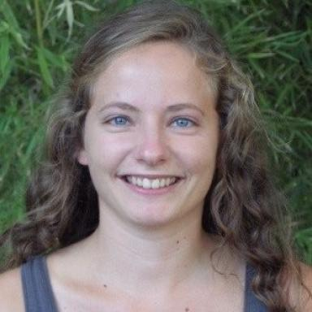 Séverine Monnot Post-Doctorante

Identifiants chercheurs

- IdHAL :
severine-monnot
- ORCID :
0000-0002-4819-3046

Présentation

Publications

Article dans une revue (3)

Genome-wide association studies to assess genetic factors controlling cucumber resistance to CABYV and CMV in crop fields and the attractiveness for their Aphis gossypii vector
Séverine Monnot,Anaïs Ravineau,Eva Coindre,Pascale Mistral,Karine Leyreet al.
Horticulture research, 2025, 12 (5), ⟨10.1093/hr/uhaf016⟩
Article dans une revue
hal-05038538v1
Unravelling cucumber resistance to several viruses via genome-wide association studies highlighted resistance hotspots and new QTLs
Severine Monnot,Melissa Cantet,Tristan Mary-Huard,Laurence Moreau,Rebecca Lowdonet al.
Horticulture research, 2022, 9, pp.uhac184. ⟨10.1093/hr/uhac184⟩
Article dans une revue
hal-03971463v1
Deciphering the Genetic Architecture of Plant Virus Resistance by GWAS, State of the Art and Potential Advances
Severine Monnot,Henri Desaint,Tristan Mary-Huard,Laurence Moreau,Valerie Schurdi-Levraudet al.
Cells, 2021, 10 (11), pp.3080. ⟨10.3390/cells10113080⟩
Article dans une revue (article de synthèse)
hal-03424384v1

Communication dans un congrès (2)

Cucurbit attractivity to Aphis gossypii is under polygenic control
Severine Monnot,Eva Coindre,Pascale Mistral,Karine Leyre,Joel Chadoeufet al.
12e réunion annuelle du réseau BAPOA, May 2022, Nice, France
Communication dans un congrès
hal-03672570v1
Adaptation of GWAS models for plant resistance to viruses: from rediscovering major genes to highlighting of new complex traits in breeding germplasm.
Severine Monnot,Laurence Moreau,Tristan Mary-Huard,Mélissa Cantet,Nathalie Boissot
XIIe Eucarpia Meeting on Cucurbit Genetics and Breeding, May 2021, Almeria, Spain. pp.1-16
Communication dans un congrès
hal-03662437v1

